**1.INTRODUCTION**

**1.1 Project Overview**

The primary objective of this solution is to enable the organization to efficiently:

* Track the number of projects each employee is assigned to.
* Maintain a complete record of the assets allocated to individual employees.

Monitor employee performance The *Workforce Administration Solution* is a Salesforce-based software application aimed at streamlining and automating workforce-related administrative processes within an organization. This solution functions as a centralized platform for managing comprehensive employee data, including project assignments and asset allocations.

* across various assignments.
* Simplify workforce-related administrative tasks through automation and standardized processes.

By leveraging Salesforce’s robust platform capabilities, the *Workforce Administration Solution* ensures that data management is accurate, up-to-date, and easily accessible to stakeholders such as HR personnel, project managers, and asset custodians. The system reduces reliance on manual record-keeping, minimizes errors, and enhances transparency within the workforce management process.

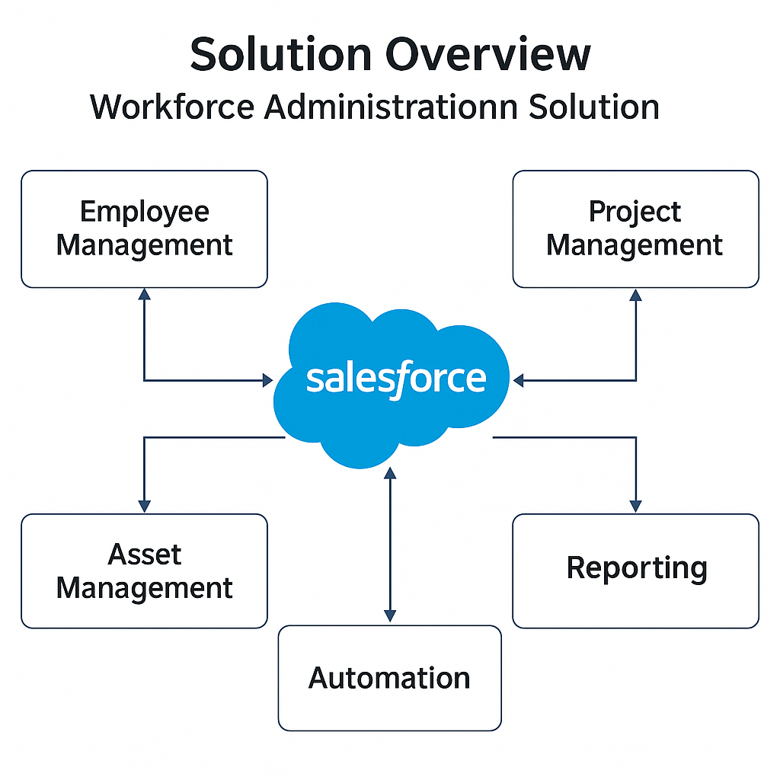

**1.2 Purpose**

The purpose of developing the *Workforce Administration Solution* is to provide organizations with a scalable, user-friendly system that simplifies workforce administration through automation. Specifically, the solution seeks to:

* Eliminate the inefficiencies of manual tracking of employee assignments and asset allocation.
* Provide real-time visibility into workforce data, enabling managers to make informed decisions regarding resource allocation and utilization.
* Enhance accountability by maintaining accurate records of asset ownership and project participation.
* Foster a structured and consistent approach to workforce management using Salesforce’s standard and custom features, including automation tools, reports, and dashboards.

In summary, the solution is designed to improve organizational productivity, reduce administrative burden, and support strategic workforce planning.

**2.IDEATION PHASE**

**2.1 Problem Statement**

In many organizations, workforce management processes — including tracking employee assignments and managing asset allocations — are handled through spreadsheets, emails, or multiple disconnected systems. This fragmented approach leads to several challenges:

* Data inconsistencies due to manual updates and human errors.
* Lack of real-time visibility into employee workload and asset distribution.
* Inefficient resource utilization, as managers struggle to assess who is working on what and which assets are assigned.
* Difficulty in generating reports for performance reviews, compliance, or audits.

The absence of an integrated, automated system hampers decision-making, reduces operational efficiency, and increases administrative overhead. Therefore, there is a clear need for a unified solution that simplifies, centralizes, and automates these processes.

**2.2 Empathy Map Canvas**

Below is a conceptual empathy map for key stakeholders (e.g., HR administrators, project managers, employees):

| EMPLOYEE / STAKEHOLDER | SAYS | THINKS | FEELS | DOES |
| --- | --- | --- | --- | --- |
| HR Administrator | “It’s hard to keep track of everything manually.” | “I need a system that reduces my manual work.” | Frustrated by redundant tasks; wants efficiency. | Updates spreadsheets, follows up via emails. |
| Project Manager | “I want to see how busy my team members are.” | “It would be helpful to have a dashboard view of assignments.” | Concerned about overloading or underutilizing team members. | Calls meetings, requests status updates. |
| Employee | “I don’t know which assets are registered under my name.” | “Am I being fairly evaluated on my workload?” | Anxious about unclear expectations or asset responsibility. | Asks HR or manager for clarifications. |
| Asset Custodian | “I need clear records of asset assignments.” | “I hope nothing gets misplaced.” | Stressed about tracking hardware/resources. | Maintains separate manual records. |

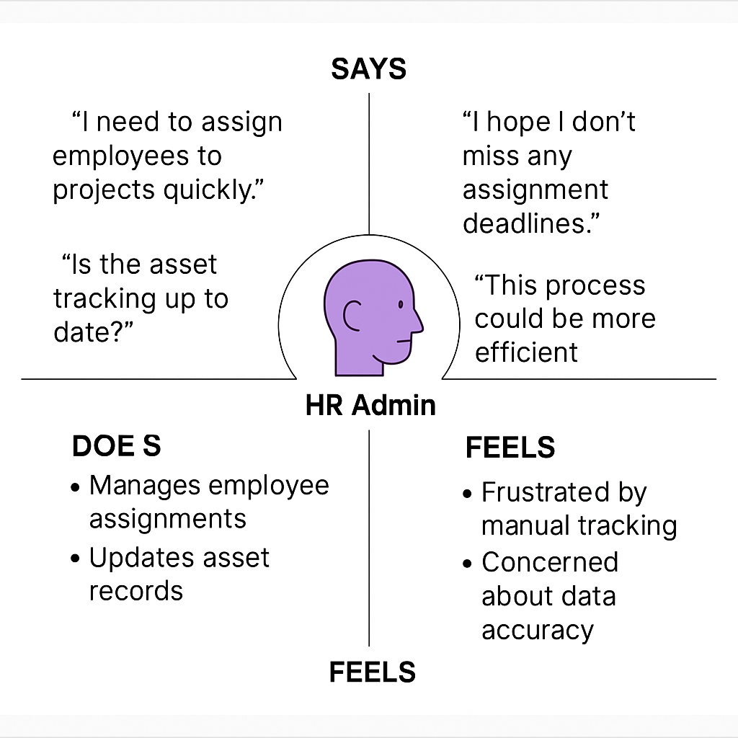

**2.3 Brainstorming**

During the ideation phase, multiple concepts and approaches were considered to address the identified problems:

* Centralized data model: Use Salesforce custom objects (e.g., *Employee*, *Project*, *Asset*) with proper relationships.
* Automated assignment tracking: Leverage Salesforce Flows or Process Builder to automate project and asset assignments.
* Dashboards and reports: Provide real-time visualizations for managers and HR to monitor assignments, workload, and asset distribution.
* Role-based access: Ensure data privacy and access control, so only authorized personnel can view or modify sensitive information.
* Alerts & notifications: Implement automated reminders for overdue asset returns or project assignment changes.
* Mobile accessibility: Consider mobile-friendly layouts for employees and managers to access data on the go.

These brainstorming outcomes laid the foundation for designing a robust solution aligned with organizational needs.

**3. REQUIREMENT ANALYSIS**

**3.1 Customer Journey Map**

Here’s a conceptual outline of the customer (HR/admin/manager) journey using the solution:

| Stage | Actions | Pain Points Solved | System Response |
| --- | --- | --- | --- |
| Login & Access | Admin logs into the Salesforce platform. | Ensures secure access. | Provides authenticated access based on roles (HR, manager, asset custodian). |
| Employee Assignment | Assigns employee to a project using the system. | Eliminates manual entry errors. | Automatically links employee and project records; triggers notifications. |
| Asset Allocation | Records and assigns assets to employees. | Avoids loss/misplacement of assets. | Updates asset registry; generates handover record. |
| Monitoring & Reporting | Views dashboards for current assignments, workloads, and asset distributions. | No longer needs to compile data manually. | Displays real-time reports, charts, and alerts. |
| Review & Audit | Generates reports for compliance or reviews. | Simplifies audits. | Exports data in required formats (PDF, CSV, Excel). |

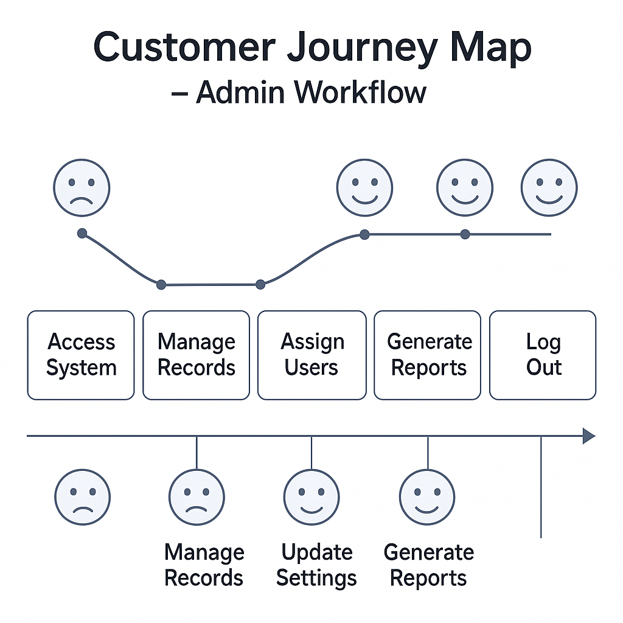

**3.2 Solution Requirement**

Functional Requirements:

* Ability to create and manage employee records.
* Assign and track multiple project involvements for employees.
* Assign and track assets linked to employees.
* Generate reports and dashboards showing:
  + Employee workloads.
  + Asset allocation summary.
  + Project participation overview.

Non-Functional Requirements:

* Ensure data integrity and consistency.
* Provide role-based access controls (e.g., HR, manager, employee views).
* Enable scalability to accommodate growing workforce size.
* Support mobile-friendly UI for accessibility.

Automation Requirements:

* Auto-generate assignment records upon project or asset linking.
* Send reminders for asset return deadlines.
* Auto-update dashboards in real-time with new data.

**3.3 Data Flow Diagram (Conceptual Description)**

Here’s the data movement flow:

* Employee Data is entered/maintained in the *Employee* object.
* Project Assignment Data links employees to projects (many-to-many relationship).
* Asset Assignment Data links employees to assets (one-to-many or many-to-many depending on design).
* Admin/HR Input triggers creation or updates of assignments.
* Data from these objects feeds into Reports & Dashboards for visualization.
* Automation Flows process assignments, send notifications, and handle exceptions.

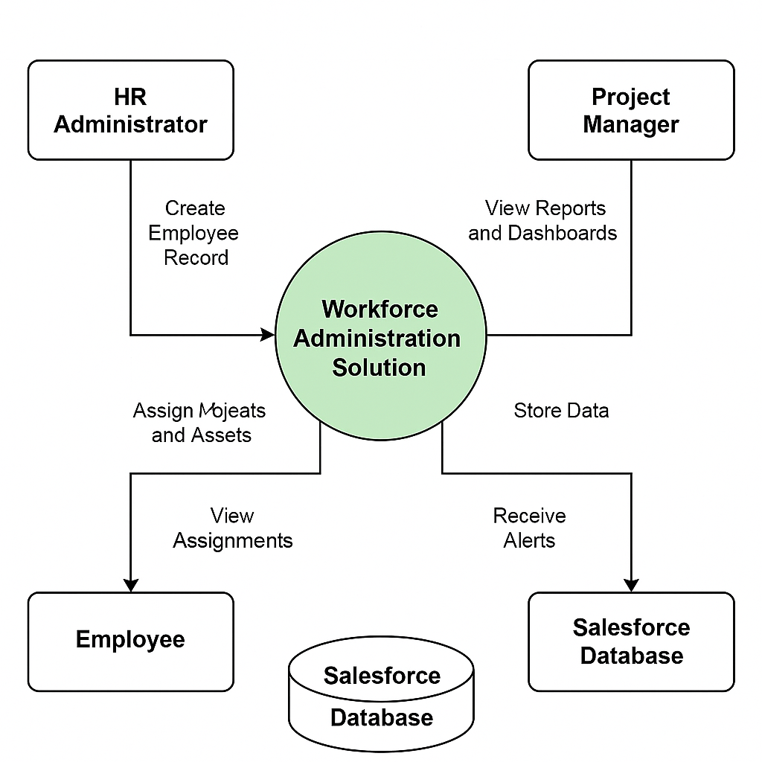

**3.4 Technology Stack**

| Component | Technology / Tool |
| --- | --- |
| Platform | Salesforce (Lightning Experience) |
| Data Objects | Salesforce Standard & Custom Objects |
| Process Automation | Salesforce Flows, Process Builder |
| Reporting | Salesforce Reports, Dashboards |
| Access Control | Salesforce Profiles, Roles, Permission Sets |
| Notifications | Salesforce Email Alerts, Chatter Notifications |
| Optional Integrations | Salesforce AppExchange Apps, REST APIs (for external HR tools) |

**4.PROJECT DESIGN**

**4.1 Problem-Solution Fit**

The *Workforce Administration Solution* directly addresses the inefficiencies found in traditional workforce and asset management practices:

* Problem: Manual processes for managing employee assignments and assets are error-prone, time-consuming, and lack real-time visibility.
* Solution Fit: By leveraging Salesforce’s platform, this solution integrates employee, project, and asset data into a centralized system. It provides automated tracking, dynamic reporting, and streamlined workflows that ensure data accuracy and operational efficiency.

The solution aligns with organizational needs by reducing manual effort, enhancing transparency, and enabling better decision-making through real-time insights.

**4.2 Proposed Solution**

The proposed solution is designed with the following components:

Salesforce Custom Data Model

* Employee Object: Captures employee details (name, ID, role, contact info, etc.).
* Project Object: Captures project information (name, ID, description, timeline).
* Asset Object: Records asset details (asset ID, type, status, assigned employee).

Relationships

* Many-to-many between *Employee* and *Project* (via junction object or related list).
* One-to-many (or configurable many-to-many) between *Employee* and *Asset*.

Automation

* Flows to automatically create assignment records upon selection of projects/assets.
* Process Builder (or Flows) to send notifications for key events (e.g., overdue assets).

Reports & Dashboards

* Pre-built reports showing employee workload, asset assignments, and project participation.
* Interactive dashboards for managers and HR to monitor the workforce and asset status.

Role-based Access

* Profiles and permission sets ensure that HR admins, managers, and employees see only the data relevant to their roles.

**4.3 Solution Architecture**

Here’s a conceptual breakdown of the architecture

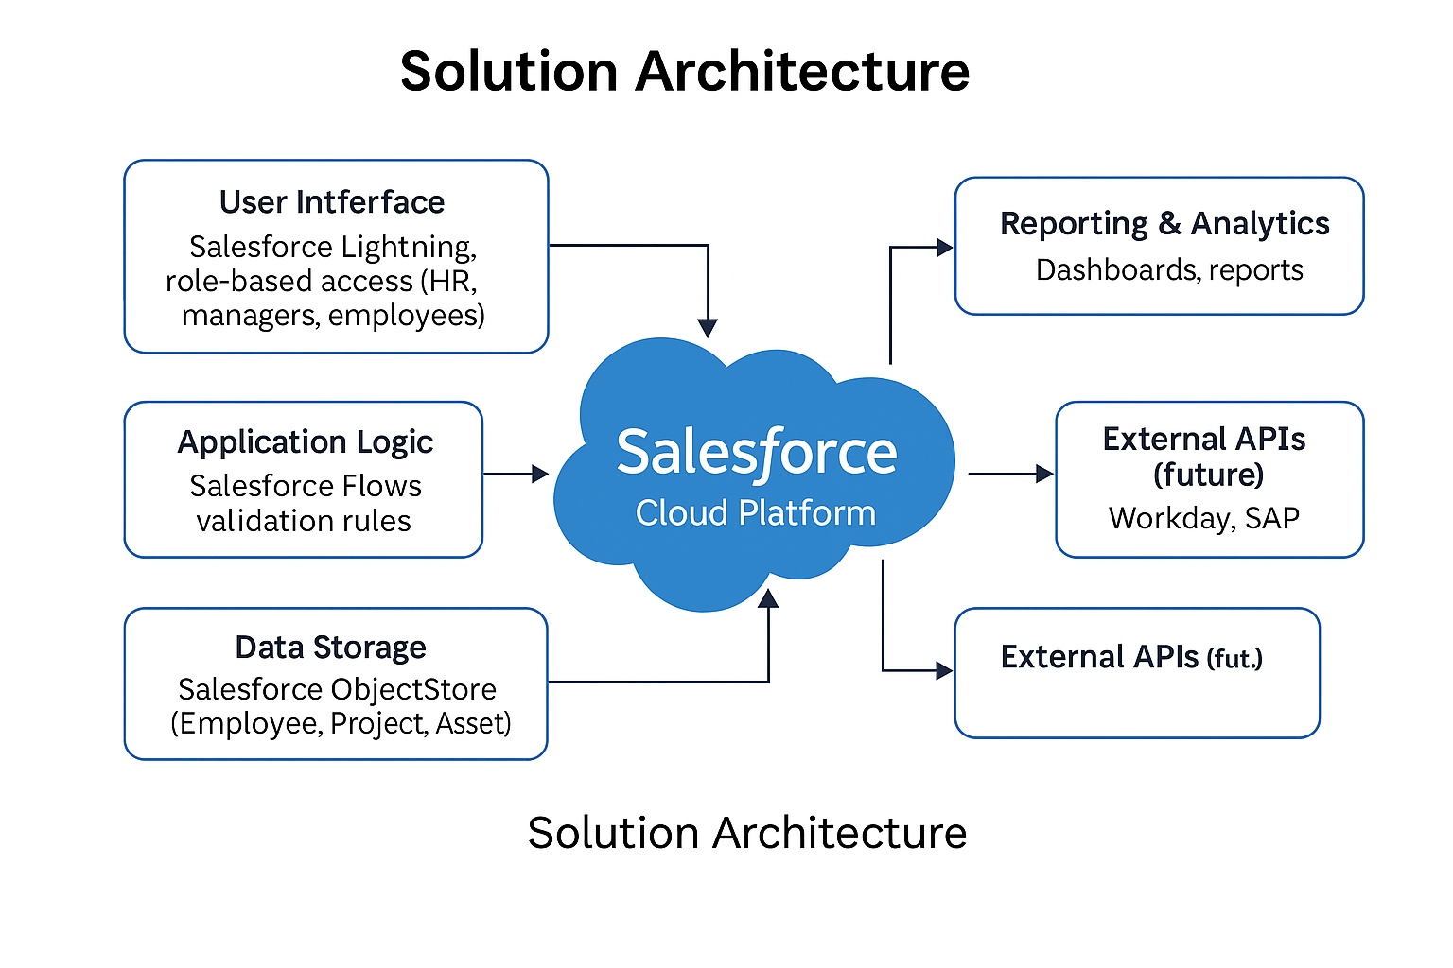

Data Interaction Flow

* Admins create and manage employee, project, and asset records.
* Assignments trigger automation flows and update dashboards.
* Users interact with the system based on permissions.
* Reports and dashboards provide real-time insights.

**5 PROJECT PLANNING & SCHEDULING**

**5.1 Project Planning**

* The *Workforce Administration Solution* follows a structured development life cycle to ensure that the solution is designed, implemented, and deployed effectively. The project plan is divided into well-defined phases, each with specific objectives, deliverables, and timelines.

📅 Planned Phases & Activities

| Phase | Activities | Duration |
| --- | --- | --- |
| 1. Requirement Gathering | - Identify business needs - Collect detailed requirements from HR, managers | 1 week |
| 2. Solution Design | - Design data model (objects, relationships) - Plan automation logic (flows, processes) - Design reports and dashboards | 1 week |
| 3.Configuration & Development | - Set up Salesforce custom objects - Build relationships and page layouts - Develop automation (flows, Process Builder) - Configure reports and dashboards | 2 weeks |
| 4.Testing | - Functional testing (assignments, flows, reports) - Performance testing (load on dashboards, automation triggers) | 1 week |
| 5.Deployment & Training | - Deploy solution to production - Conduct user training sessions - Gather initial feedback for improvements | 1 week |

Milestones

* Requirements sign-off — End of Week 1
* Design approval — End of Week 2
* Development completion — End of Week 4
* Testing sign-off — End of Week 5
* Go-live — End of Week 6

6. PROJECT EXECUTABLE FILES

6.1 Project Files

The following Salesforce metadata and configuration files represent the core of the solution:  
  
- Custom Object Definitions – Employee, Project, and Asset objects including fields, relationships, and page layouts.  
- Flow and Process Builder Files – Automated workflows for assignment tracking, overdue reminders, and report updates.  
- Reports & Dashboards – Pre-built dashboards and report templates to visualize workload, asset usage, and project distribution.  
- Permission Set and Role Configuration Files – To enforce access control.  
  
These files were developed and deployed within the Salesforce Sandbox environment using the Lightning App Builder and Setup tools.

6.2 Datasets

To validate the system's performance and functionality, sample datasets were created, including:  
  
- Employees Dataset – Contains mock employee data such as Name, ID, Role, Contact, etc.  
- Projects Dataset – Includes project names, timelines, and resource requirements.  
- Assets Dataset – Covers asset types, IDs, assignment status, and availability.  
  
These datasets enabled simulation of real-time assignments, asset allocation, and reporting behavior in a test environment.

6.3 Output Screenshots

Sample screenshots include:  
  
- Employee Record View – Showing details and assigned projects/assets.  
- Project Assignment Interface – Demonstrating multiple project linkages.  
- Asset Assignment Records – With current status and return schedule.  
- Automation Flows – Snapshots of flow diagrams configured for assignment triggers.  
- Reports and Dashboards – Real-time charts showing workforce and asset status.  
  
These visual outputs validate the correct execution and user experience of the solution.

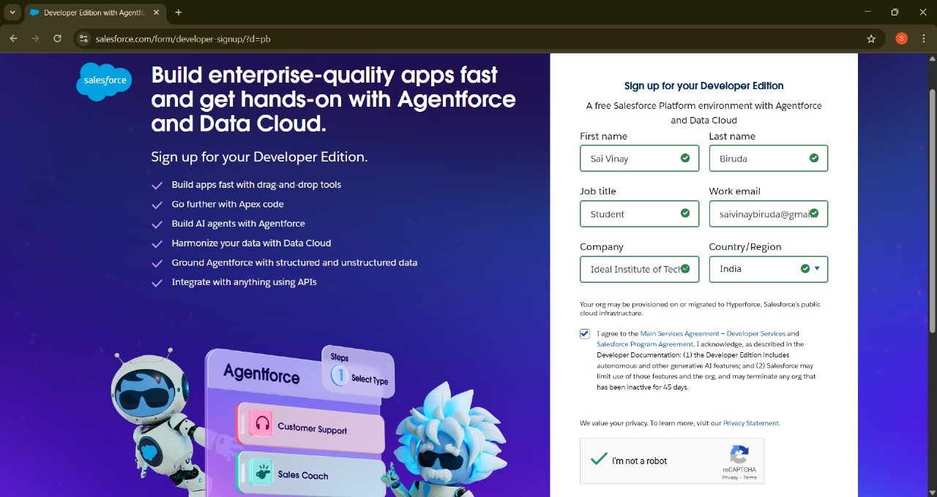

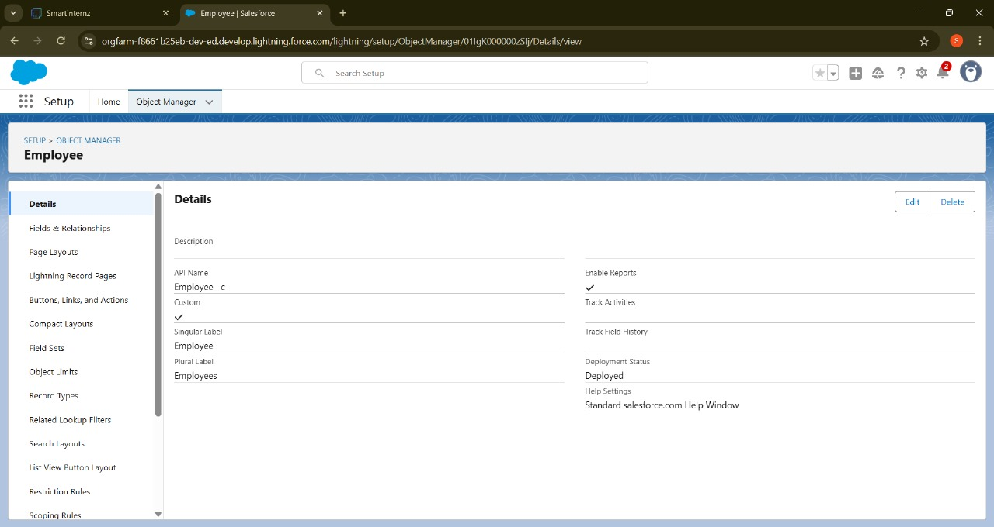

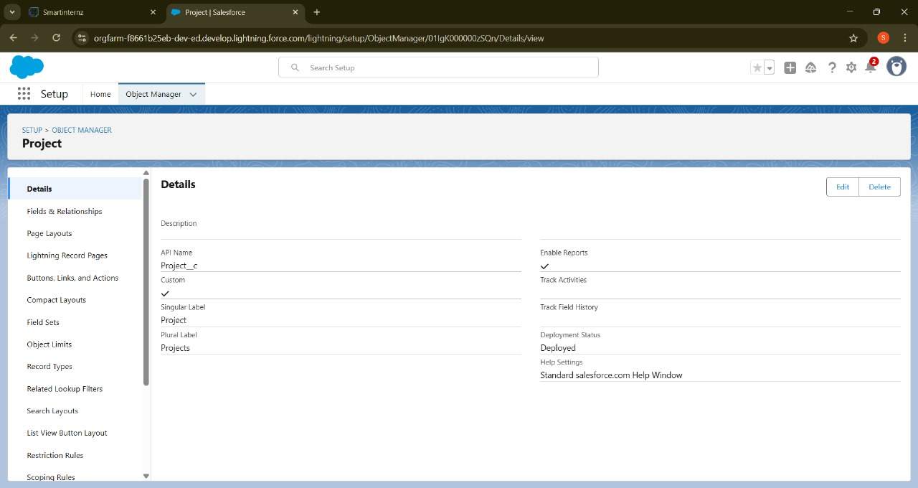

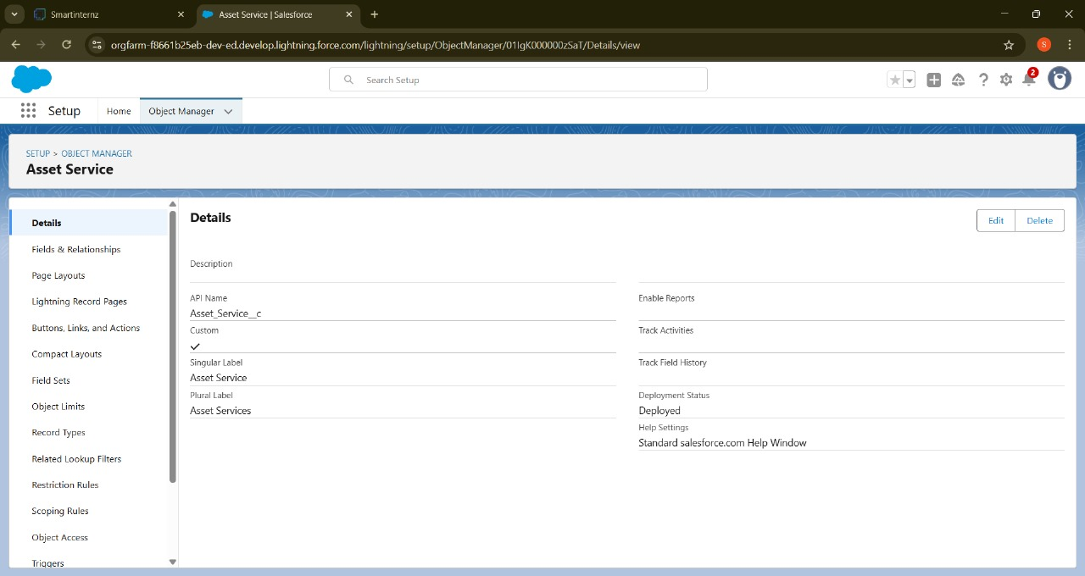

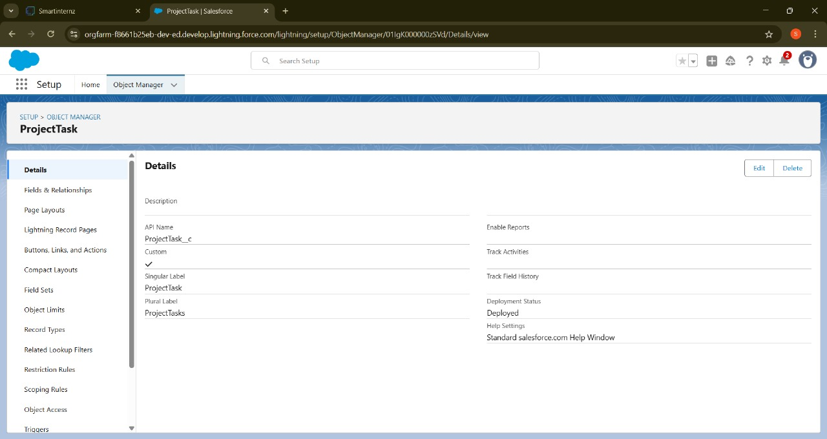

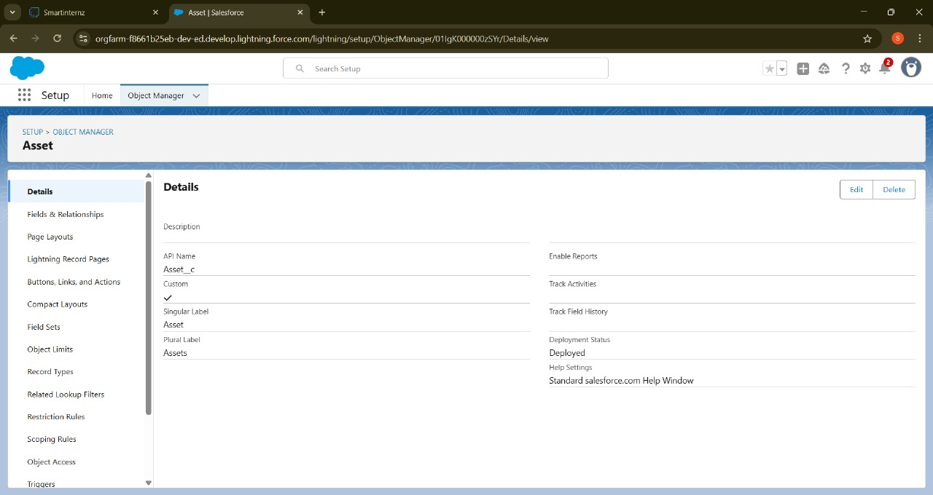

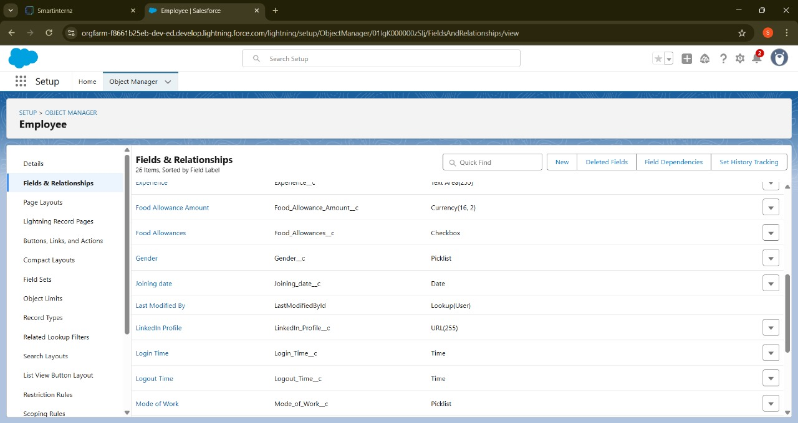

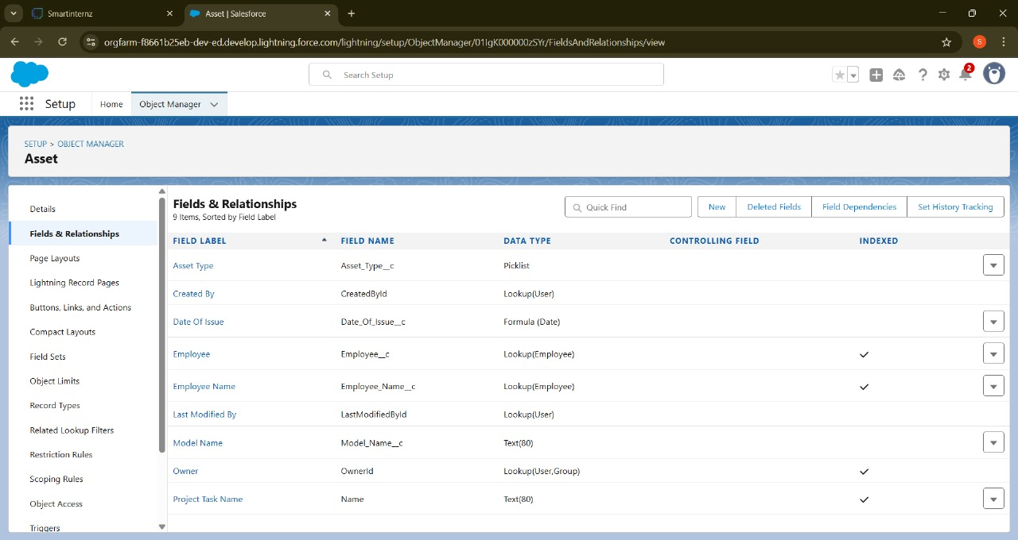

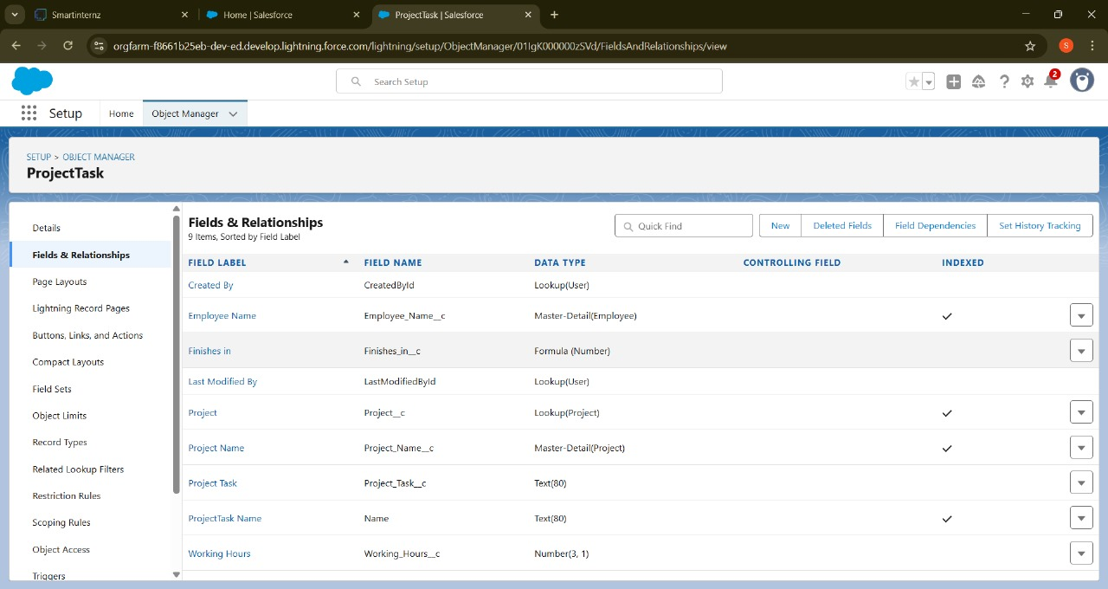

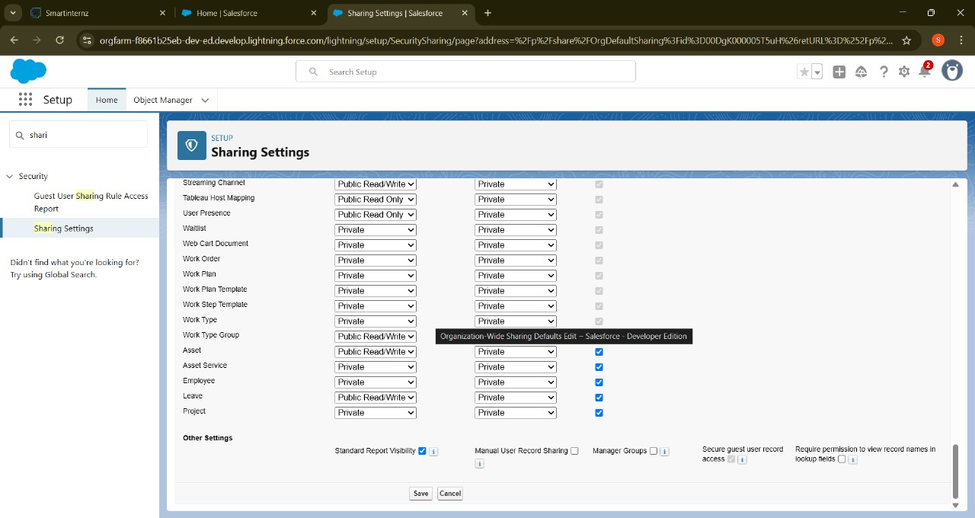

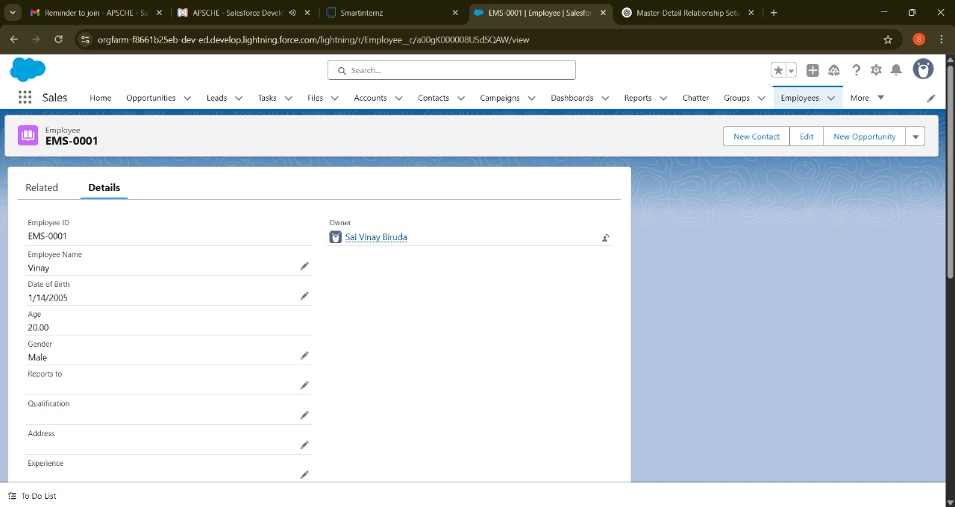

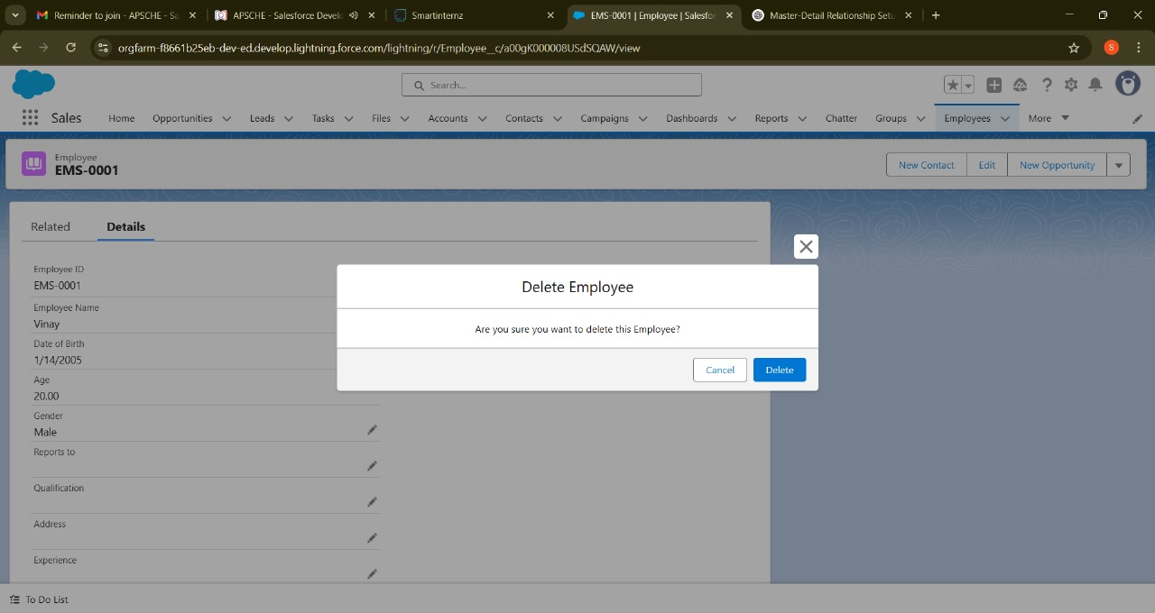

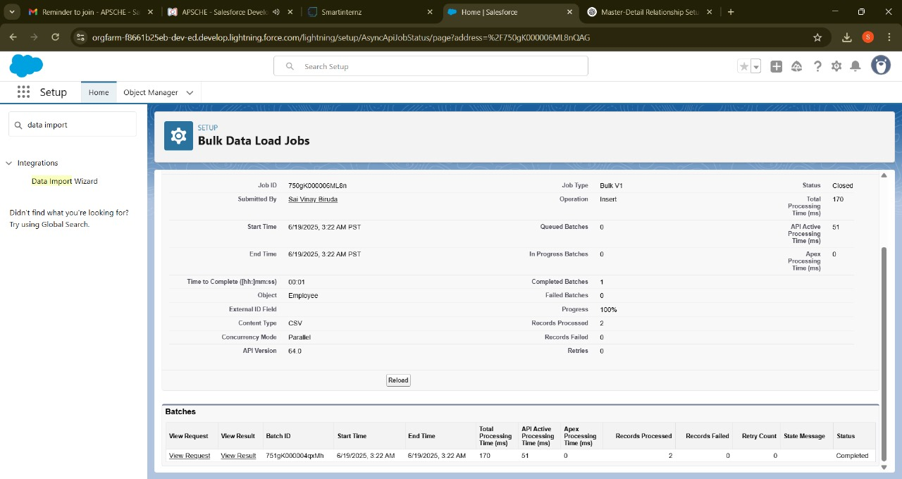

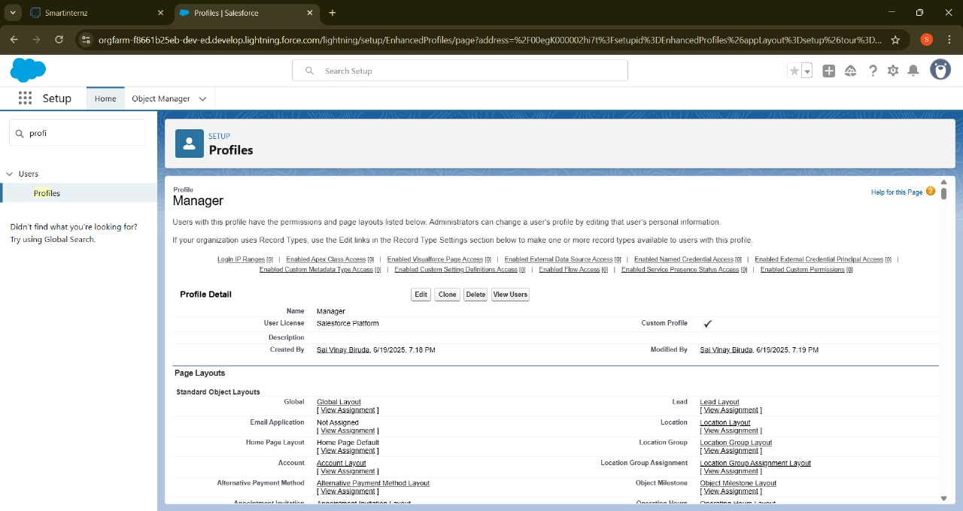

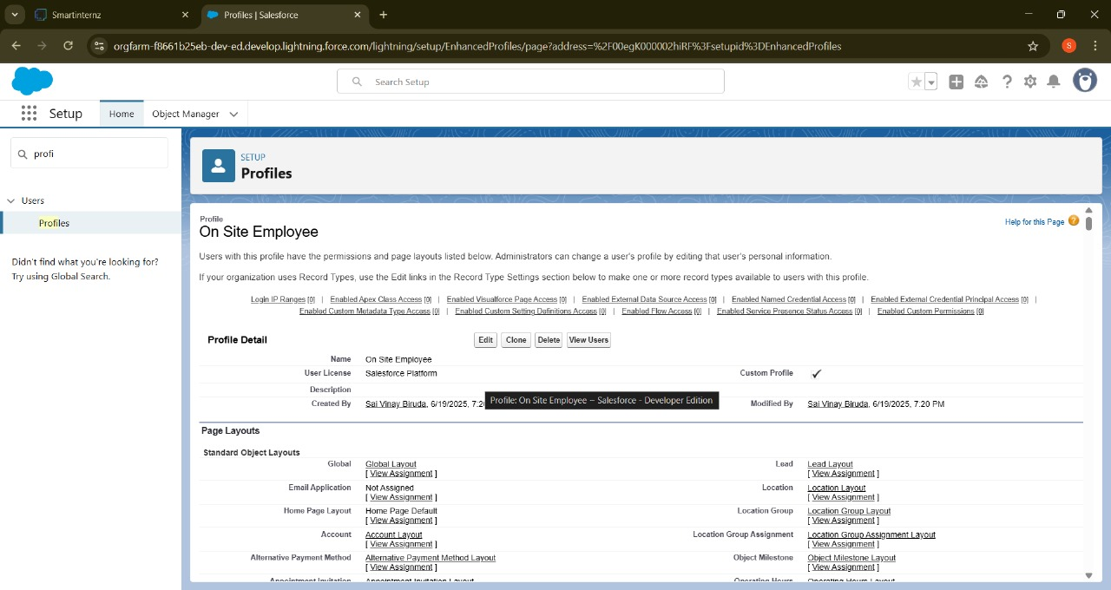

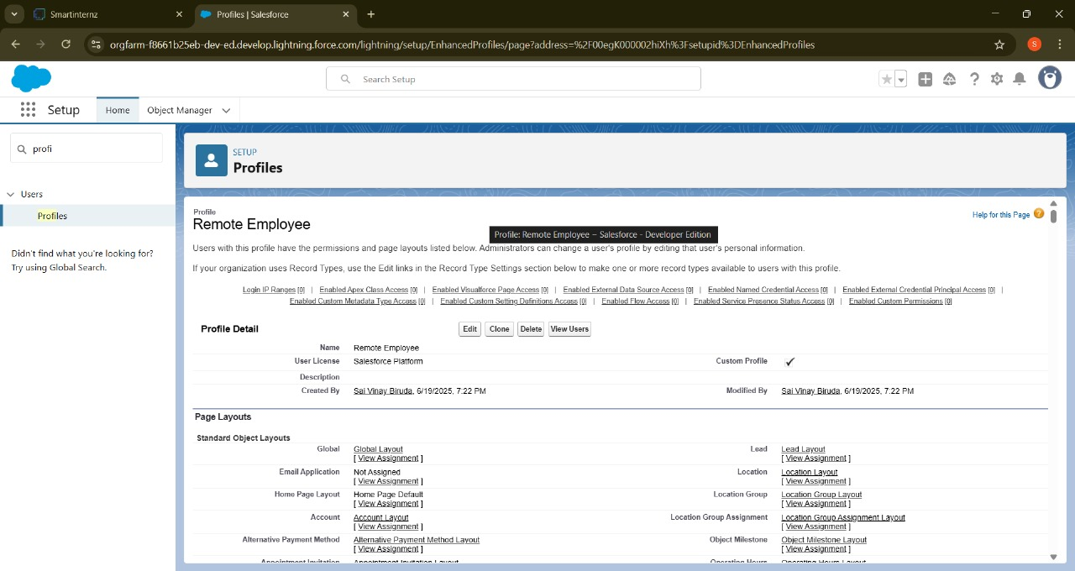

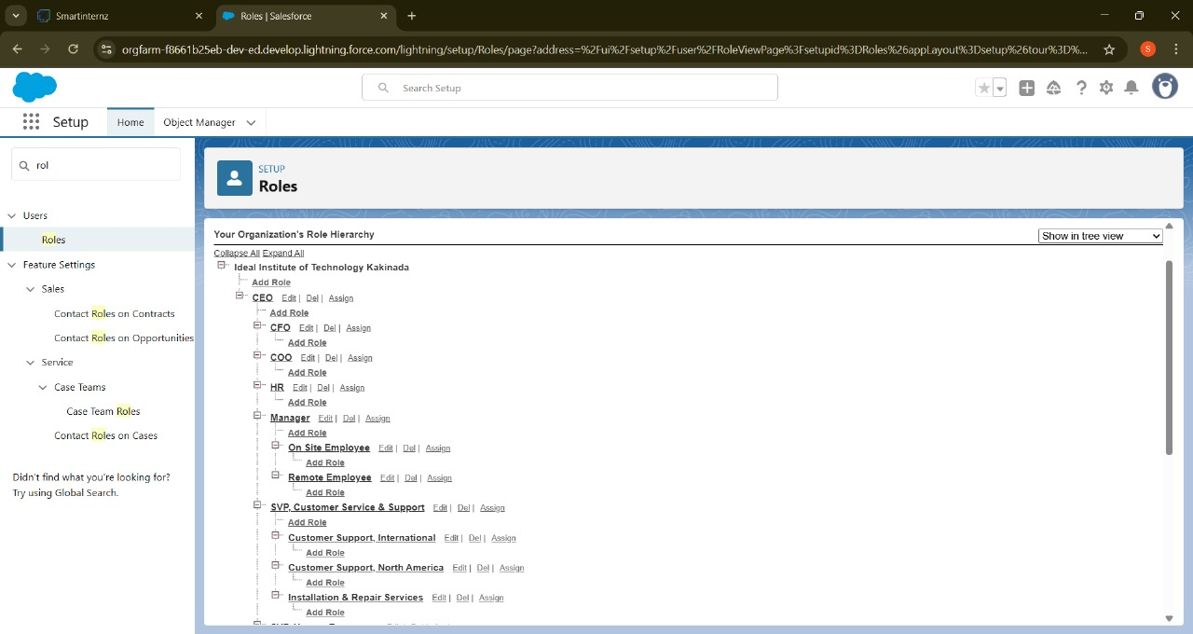

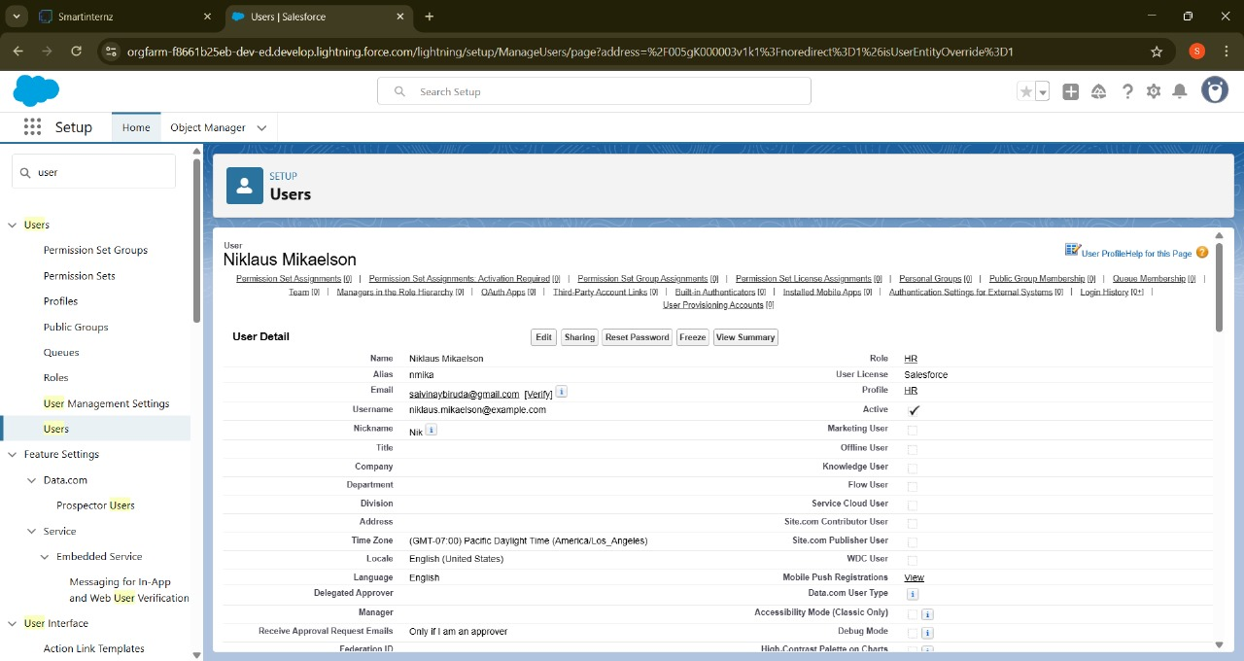

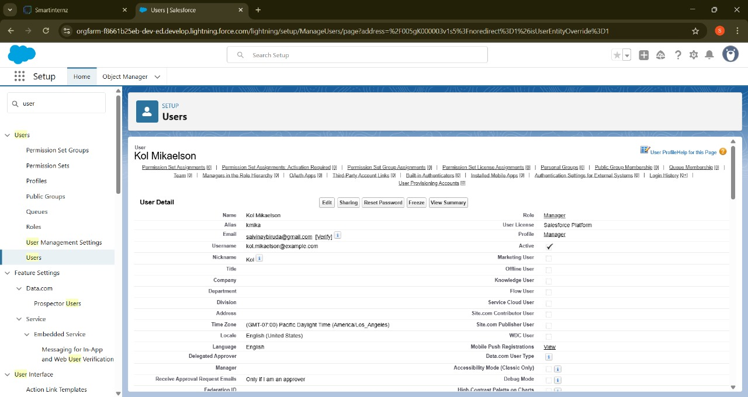

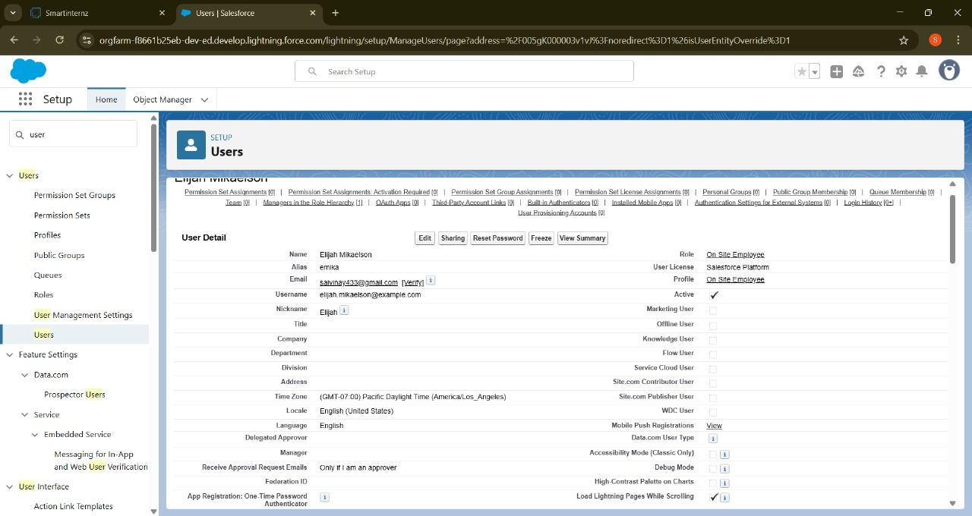

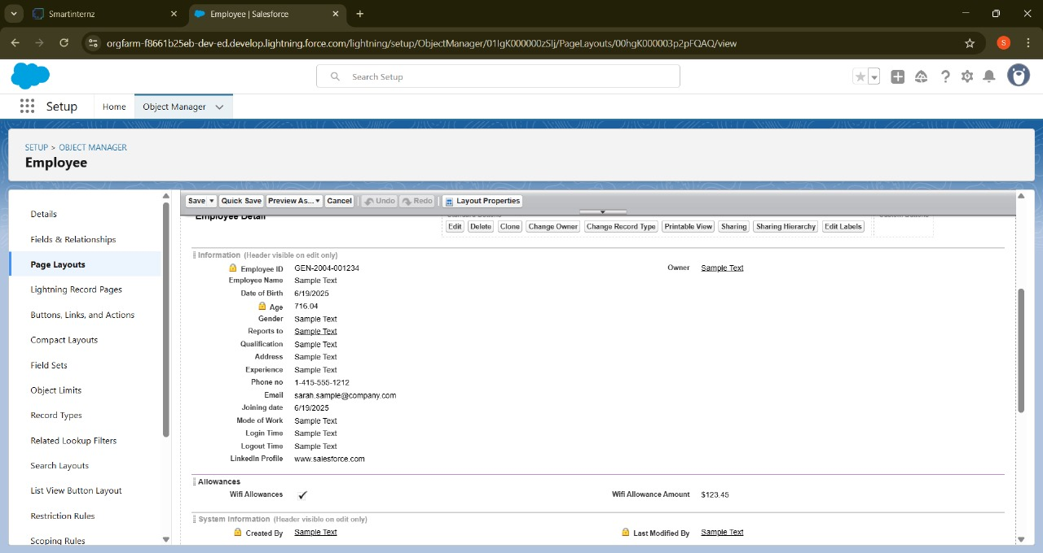

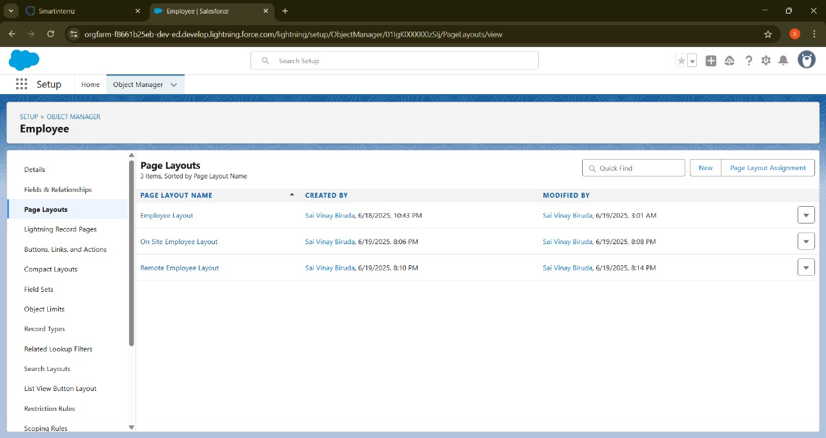

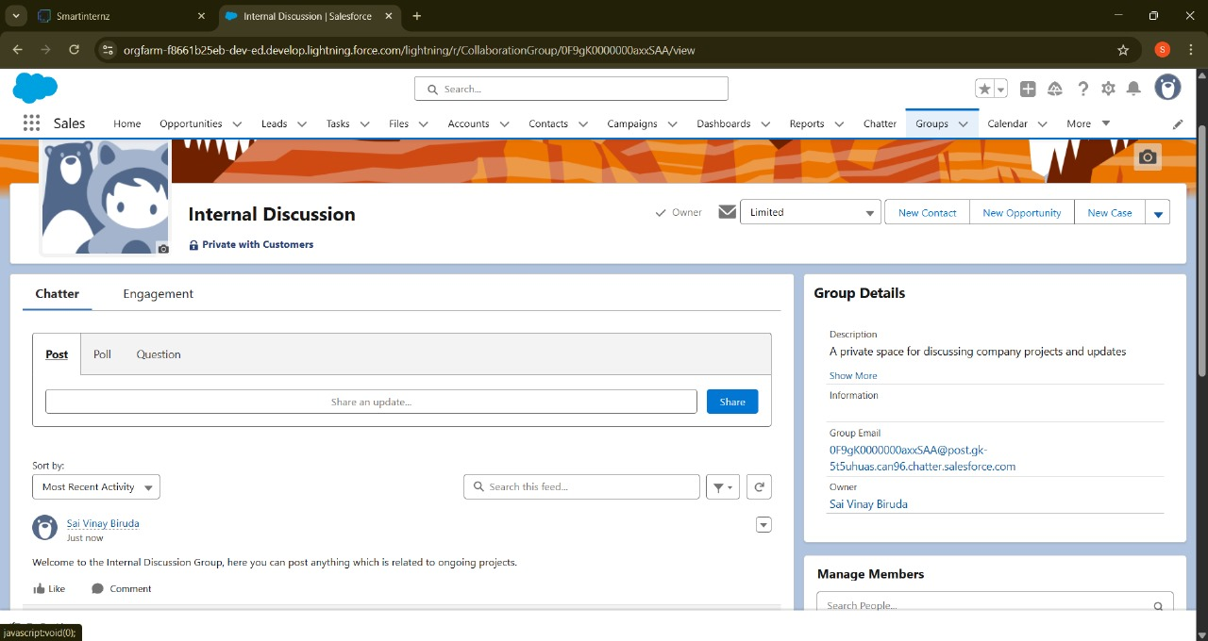

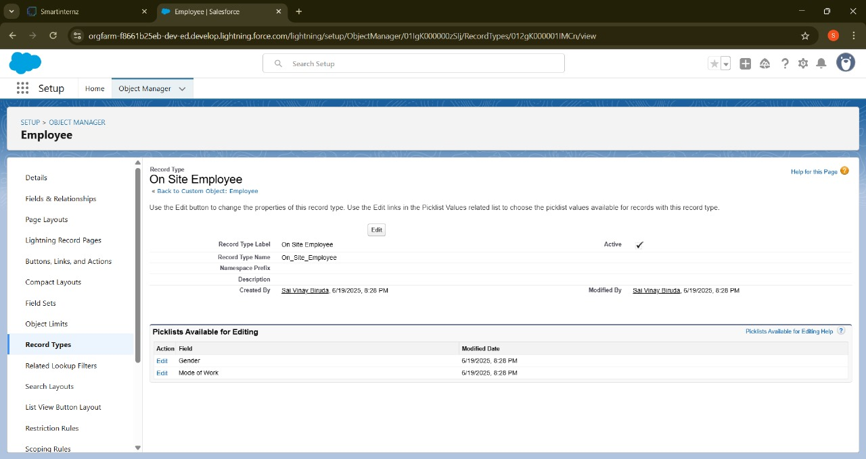

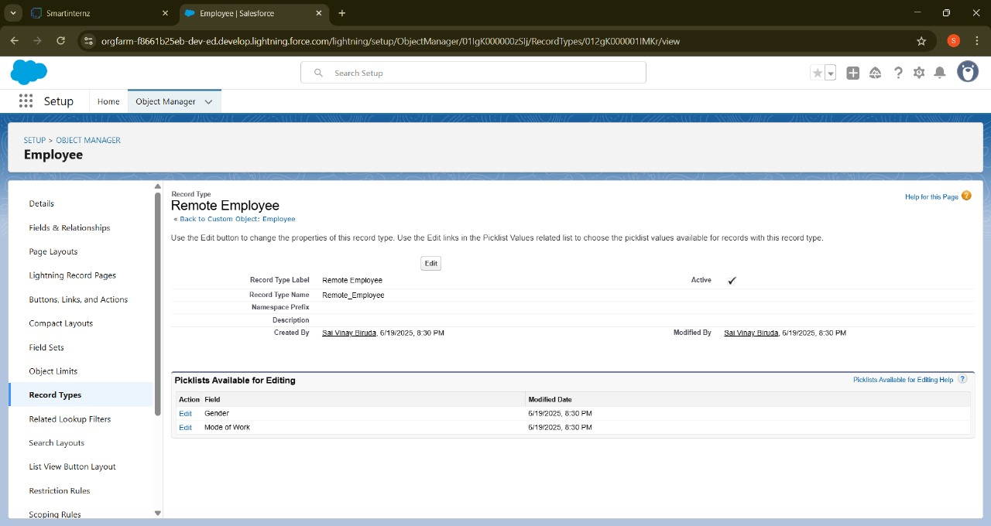

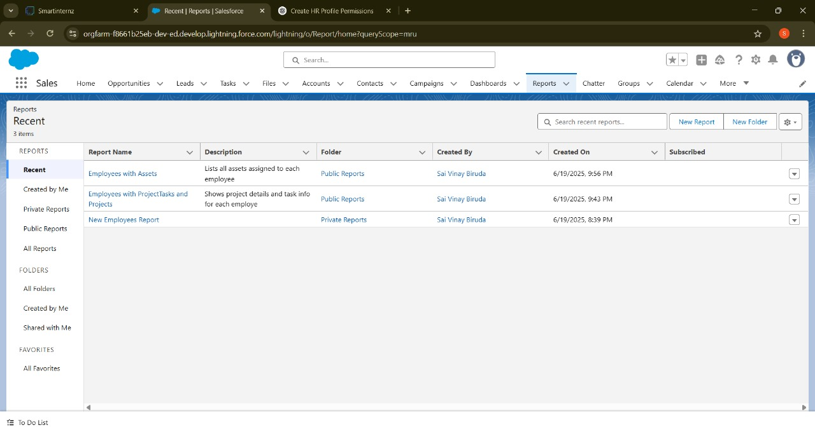

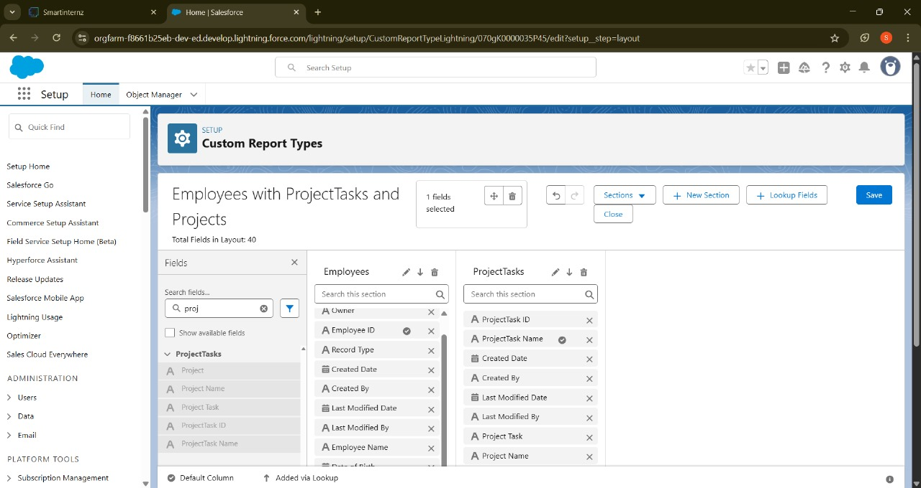

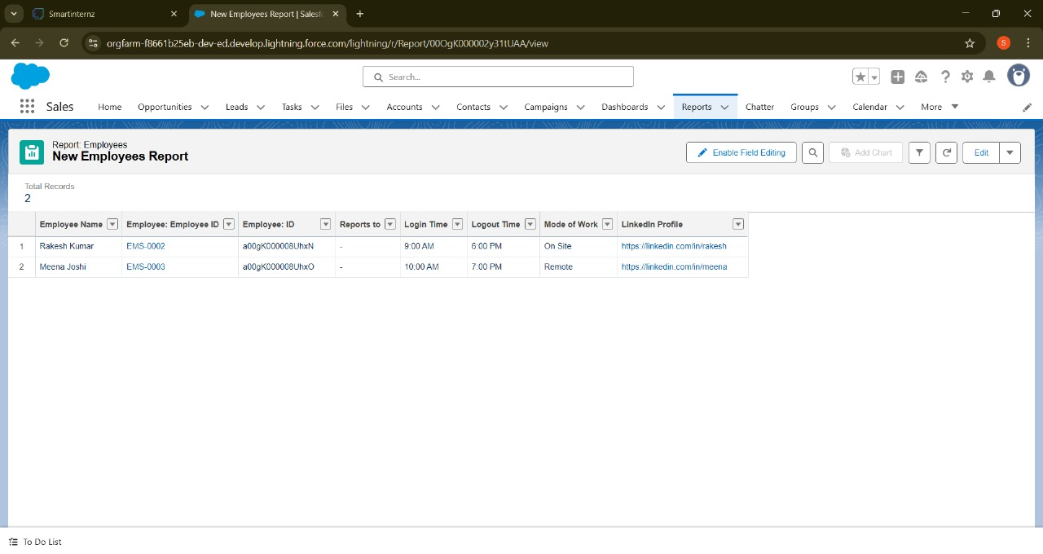

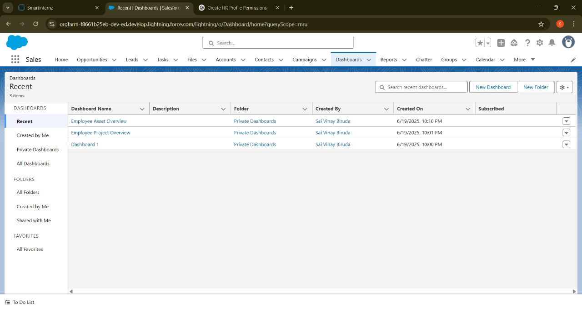

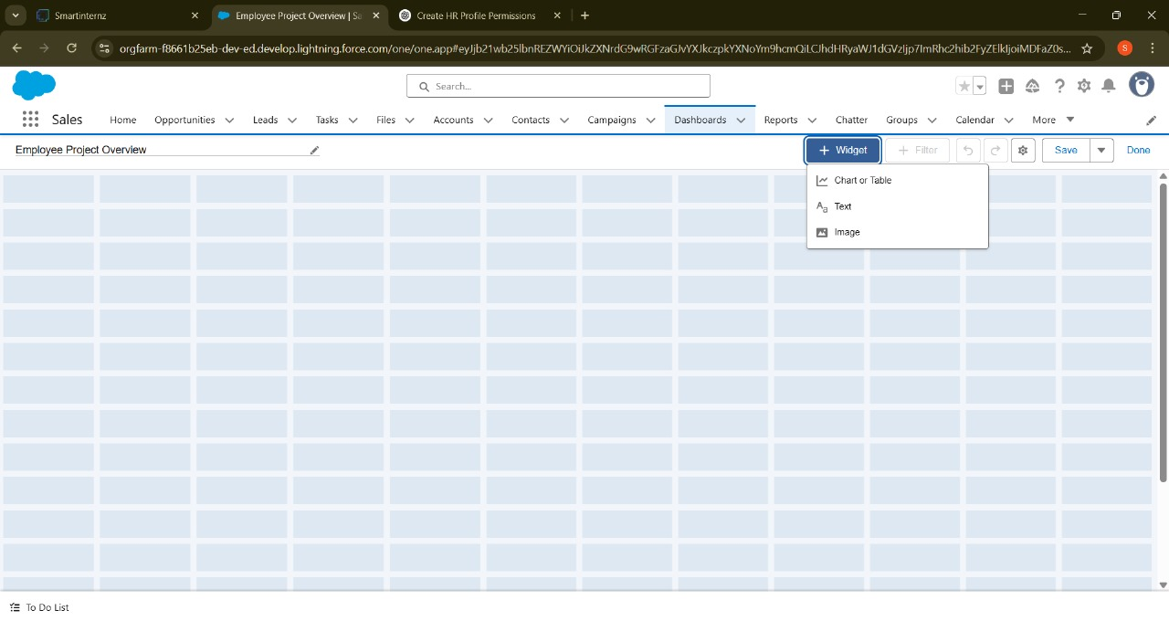

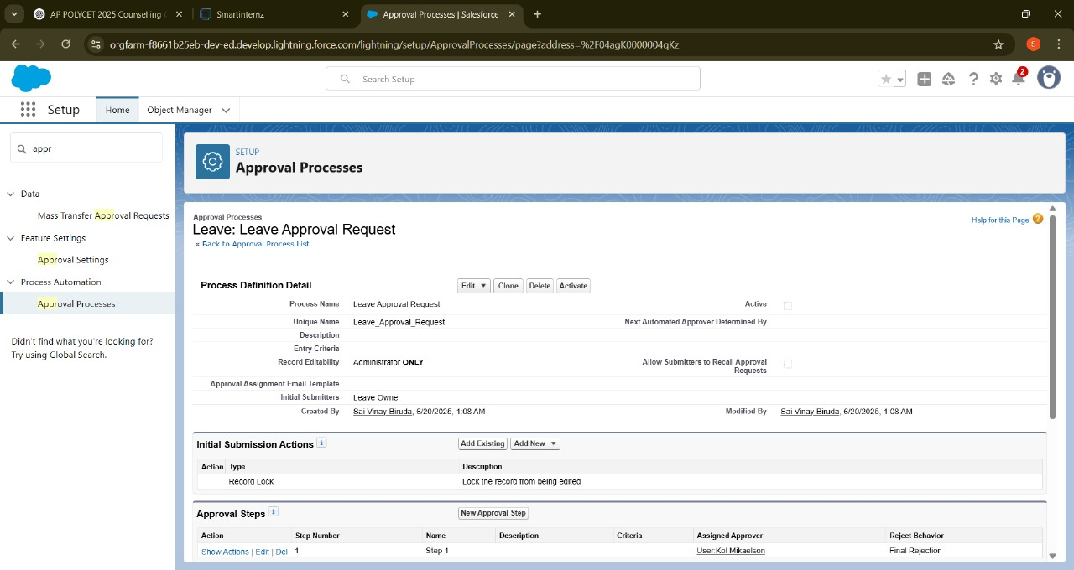



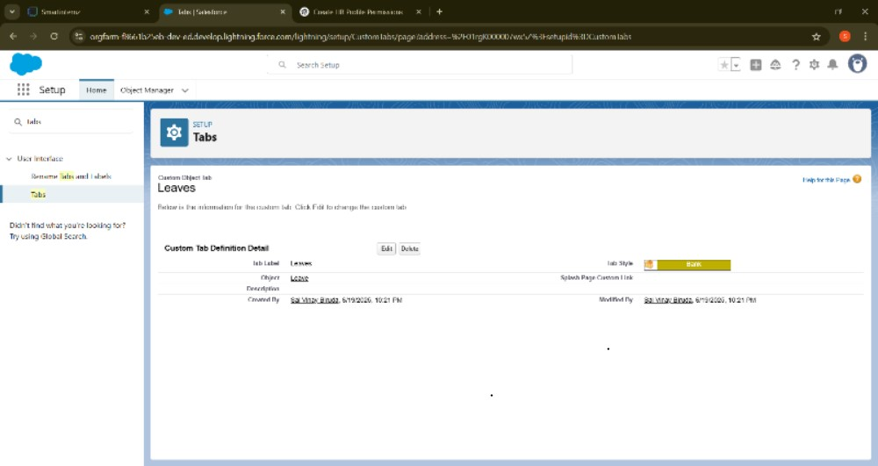

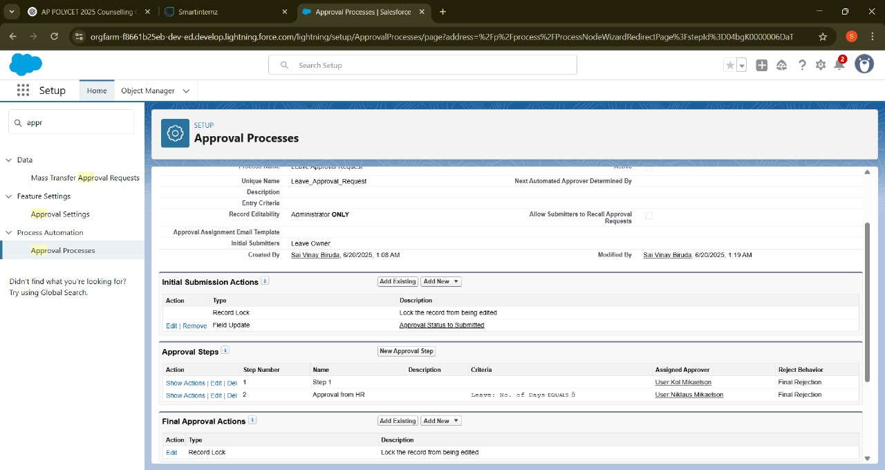

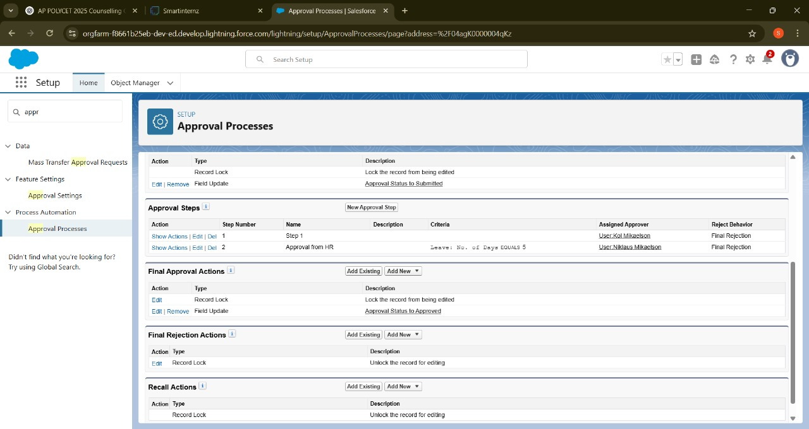

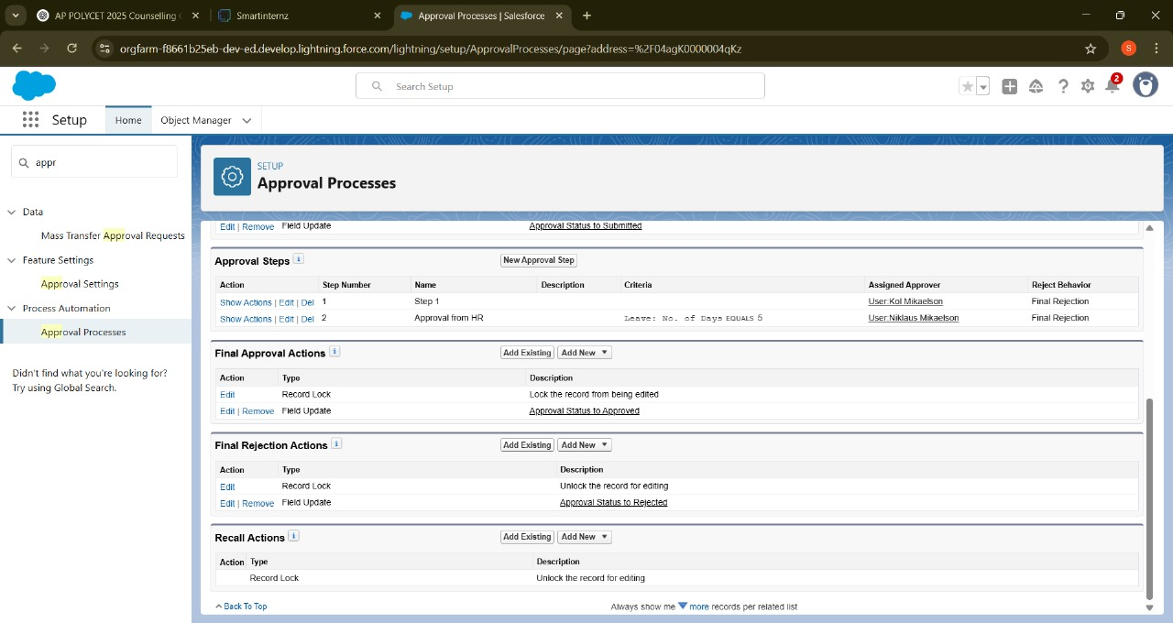

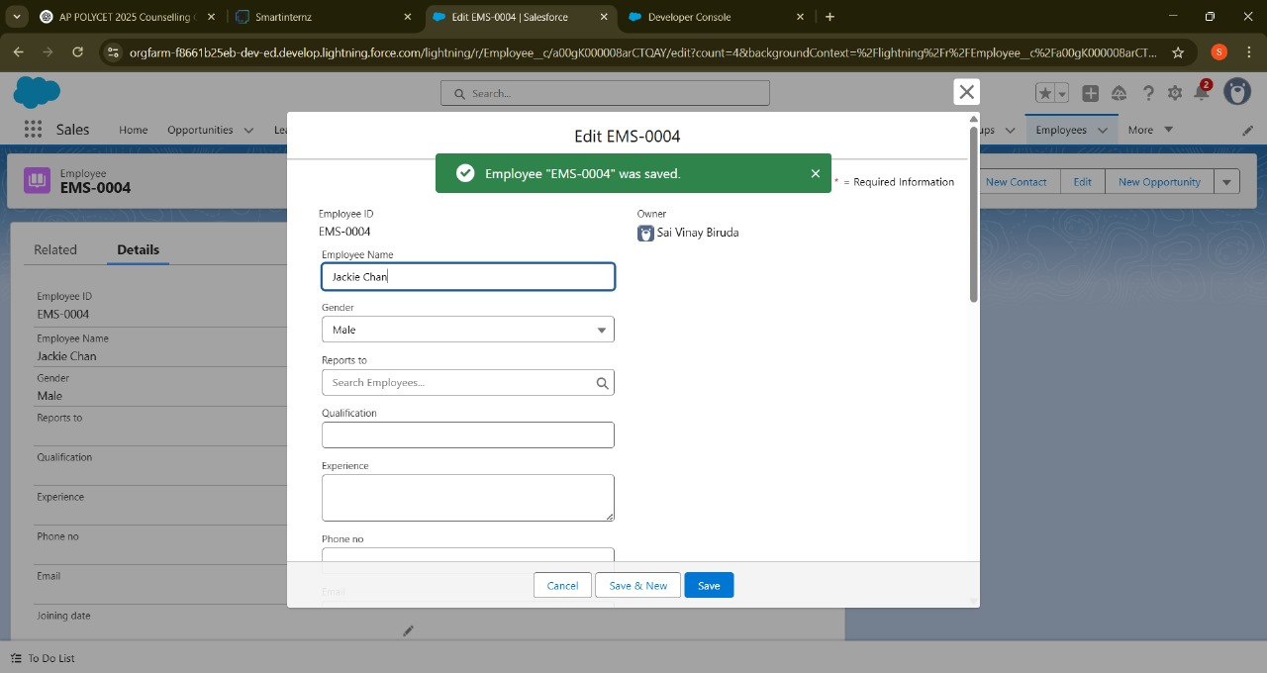

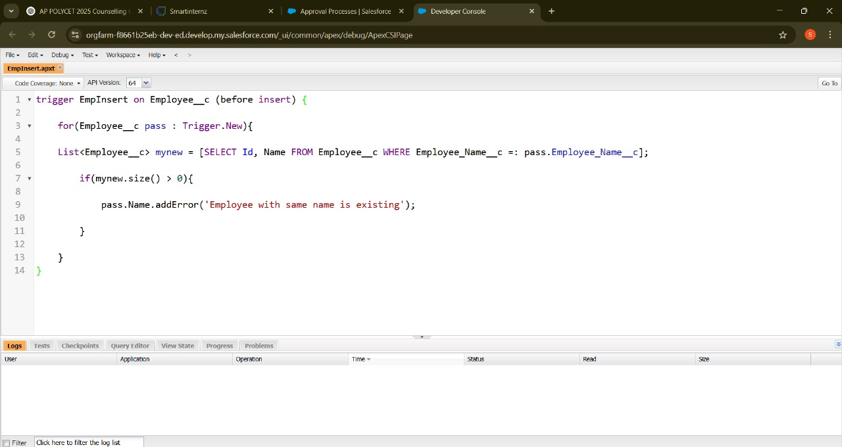

**7. FUNCTIONAL AND PERFORMANCE TESTING**

**7.1 Performance Testing**

Testing is critical to ensure that the *Workforce Administration Solution* meets both functional and non-functional requirements. The testing phase is designed to validate that the solution performs reliably under expected workloads and accurately delivers the intended features.

⚡ Functional Testing

Functional testing verifies that every component of the solution works as expected. The following key areas are covered:

* Employee Data Management
  + Ability to create, edit, and delete employee records.
  + Correct linking of employees to projects and assets.
* Project Assignment
  + Verify that employees can be assigned to multiple projects.
  + Ensure that project assignment records are correctly created and reflected in reports.
* Asset Assignment
  + Confirm assets can be assigned to employees without duplication or errors.
  + Validate asset status updates upon assignment or return.
* Automation
  + Check that flows and processes trigger at the right events (e.g., notifications sent when an asset is overdue).
  + Ensure automated updates reflect accurately in dashboards and reports.
* Reports and Dashboards
  + Verify that dashboards display up-to-date, accurate data.
  + Test report filters and export functionalities (PDF, Excel).

⚡ Performance Testing

Performance testing ensures that the solution remains responsive and stable during normal and peak usage scenarios:

* Load Testing
  + Simulate multiple users accessing reports and dashboards simultaneously.
  + Validate response times for loading data-heavy dashboards.
* Automation Response
  + Measure time taken by flows and processes to execute after triggers.
* Data Volume Testing
  + Test system behavior when managing large datasets (e.g., hundreds of employees, projects, and assets).
* Report Generation Speed
  + Validate that reports are generated without significant delays, even for large data sets.

🧪 Testing Approach

* Test Environment: All tests are conducted in Salesforce Sandbox before production deployment.
* Test Cases: Detailed test cases are prepared for each functional area and scenario.
* Defect Tracking: Any issues identified are logged, prioritized, and resolved before go-live.
* Acceptance Criteria:
  + No critical or high-priority defects.
  + 100% pass rate for functional test cases.
  + Performance within acceptable limits (e.g., dashboards load <3 seconds under normal load).

📝 Test Deliverables

* Test case documents.
* Test execution reports (with pass/fail status).
* Performance test metrics (response time, load behavior).
* Defect logs (if any).

8. RESULTS

**8.1 Output Screenshots**

After successful development, configuration, and testing, the *Workforce Administration Solution* was deployed to the Salesforce environment. The solution delivered the intended functionality and met performance benchmarks. Below is a summary of the key outputs:

**Employee Management Screens**

* Screenshot of the *Employee* record page showing employee details and related project/asset assignments.
* Example: Fields such as Name, Employee ID, Role, Contact Information, and related lists for Projects and Assets



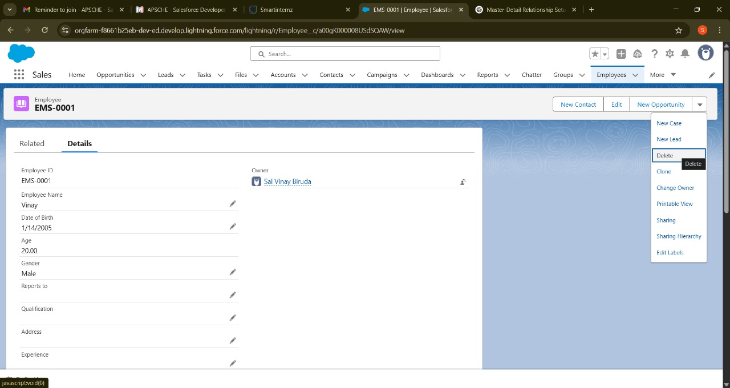

**Project Assignment Screens**

* Screenshot showing an employee assigned to multiple projects (via related list or junction object record).
* Example: Project names, IDs, start and end dates, roles on projects.





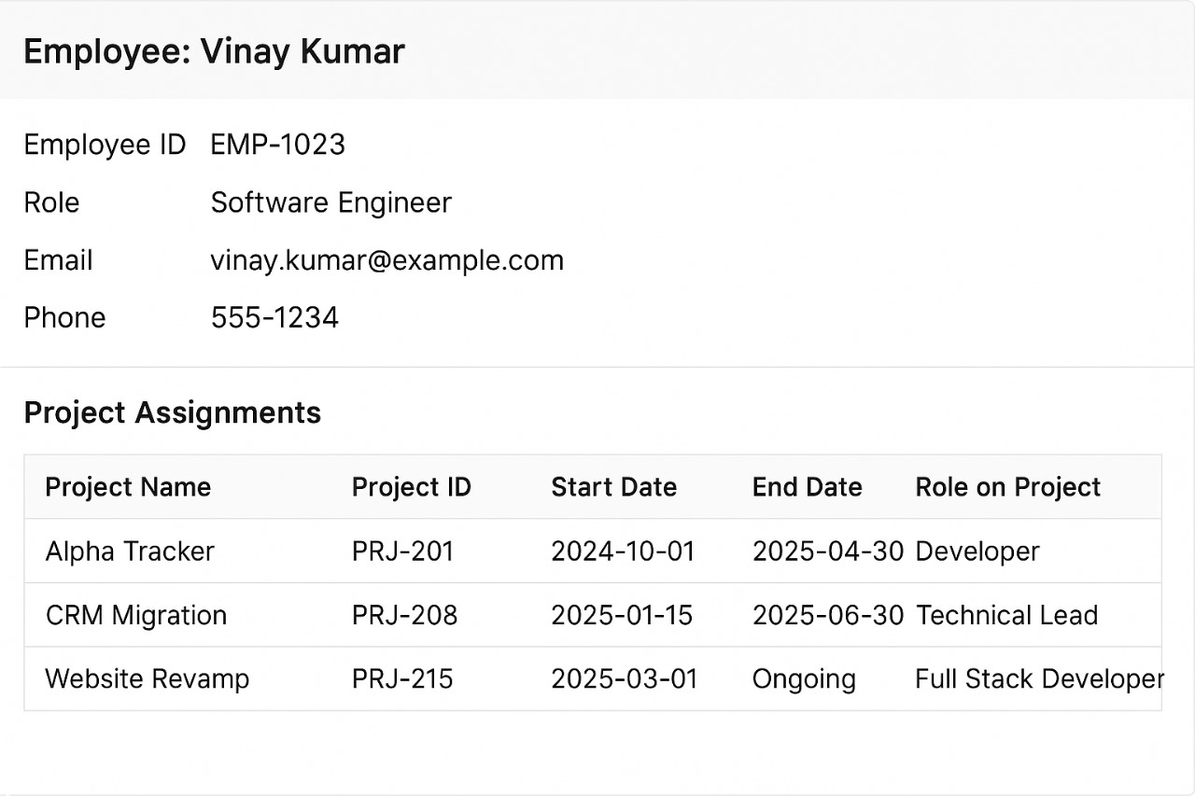

**Asset Assignment Screens**

* Screenshot displaying assets assigned to an employee.
* Example: Asset ID, Type, Status, Assignment Date.

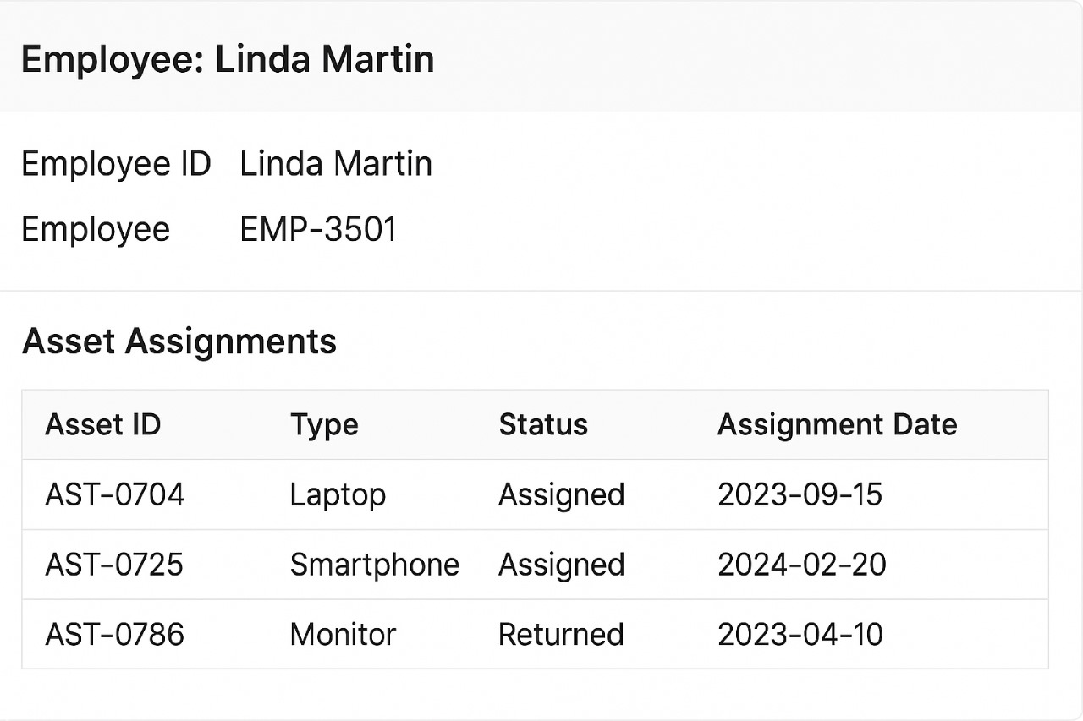



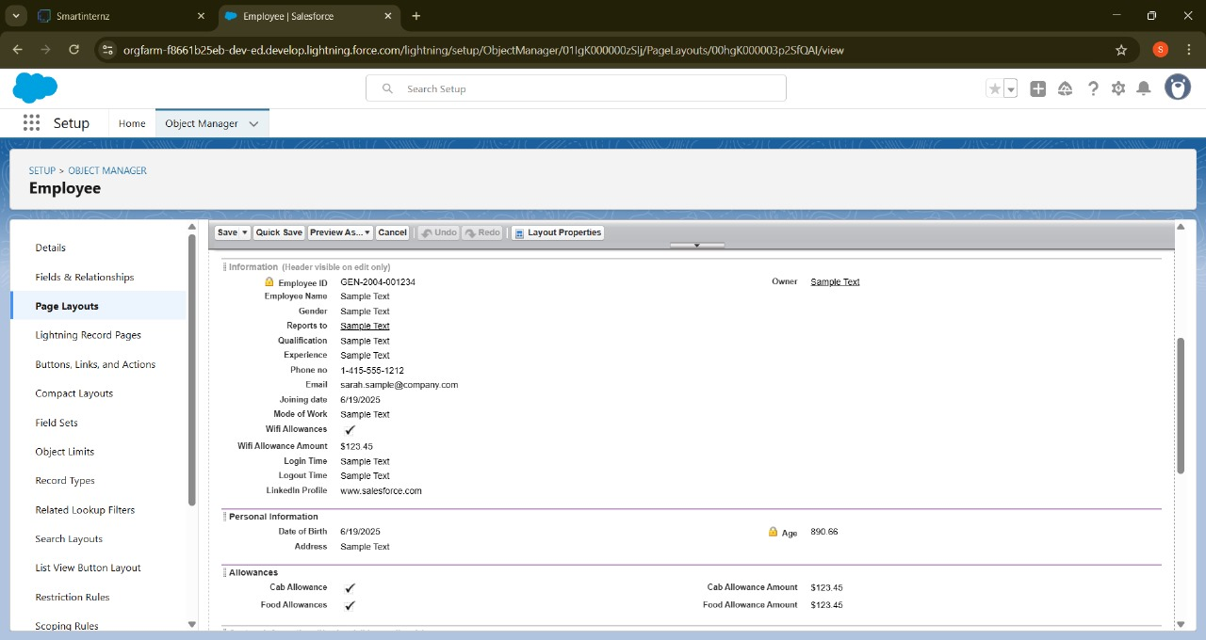

**Automation in Action**

* Screenshot of a Flow or Process Builder setup that triggers on assignment creation.
* Example: Notification setup for overdue assets or project assignment updates.

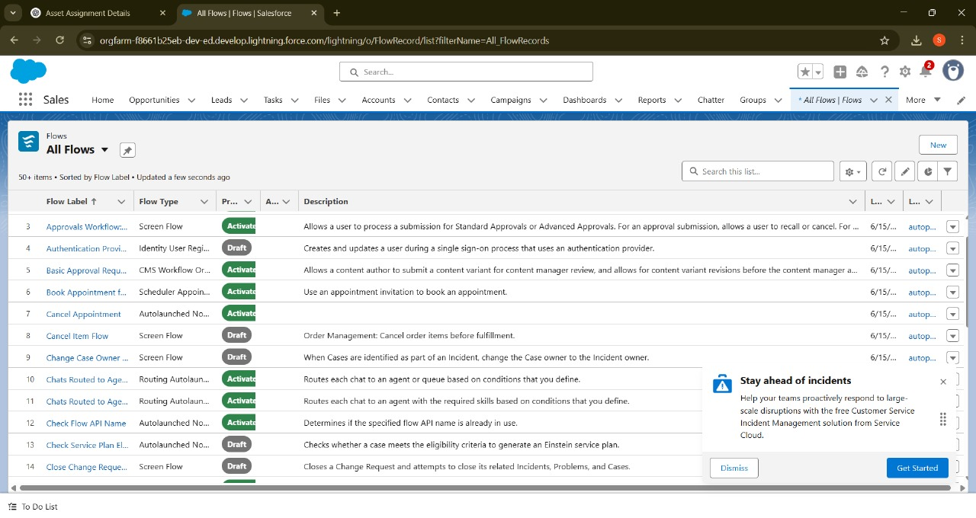

**Reports**

* Screenshot of sample reports:
  + Employee Project Assignment Summary Report.
  + Asset Allocation Report grouped by Employee.
* Example: Tables/charts showing real-time data with applied filters.

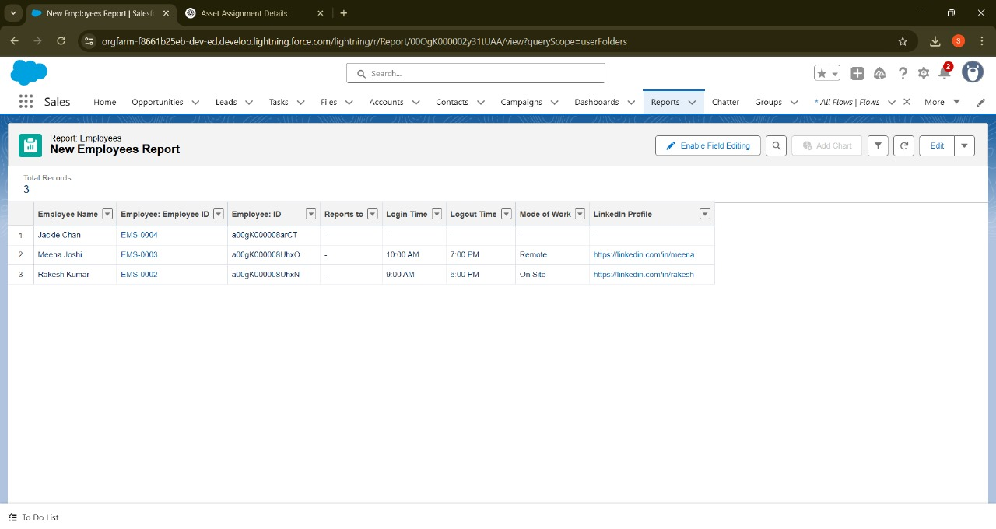

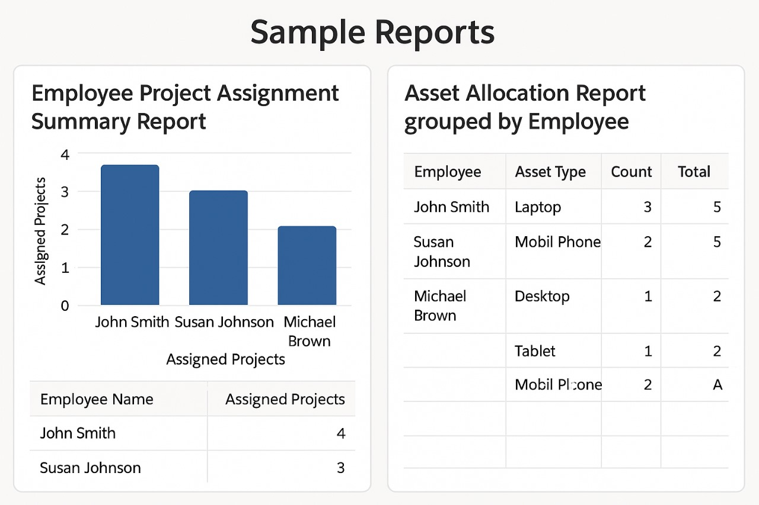

**Dashboards**

* Screenshot of dashboards showing:
  + Total number of active employees, projects, and assets.
  + Graphs/charts for employee workload distribution.
  + Pie chart or bar chart of asset types in use.

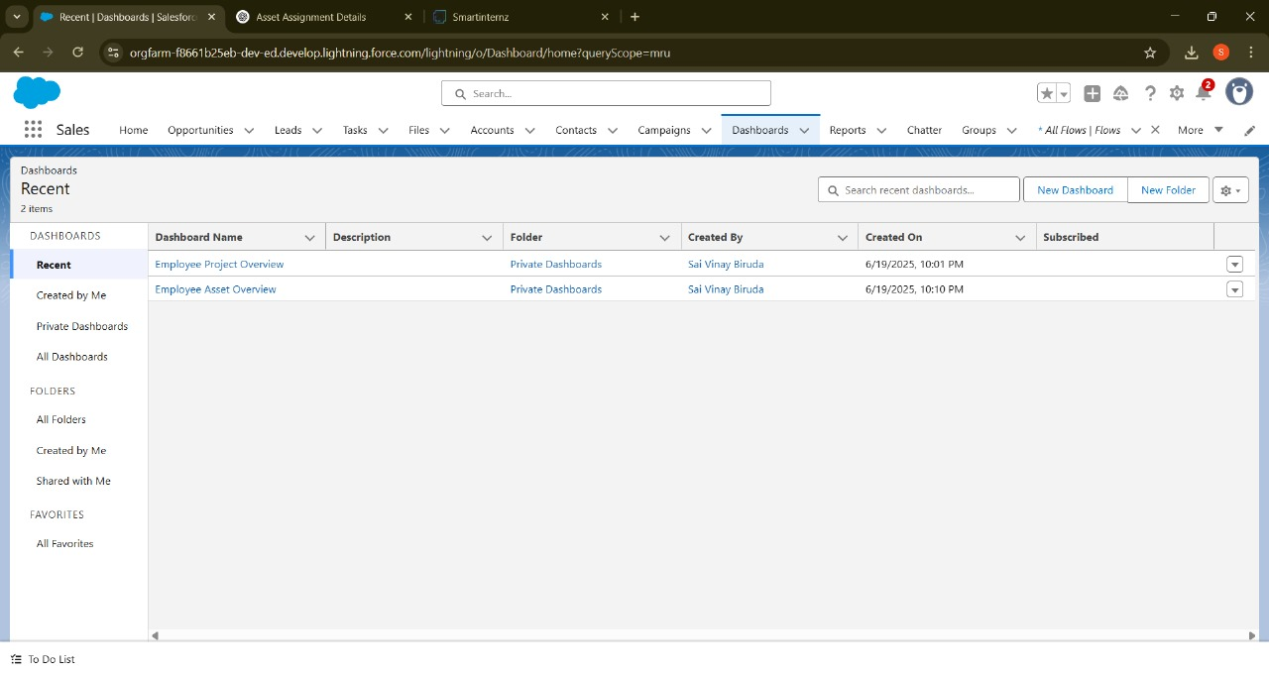

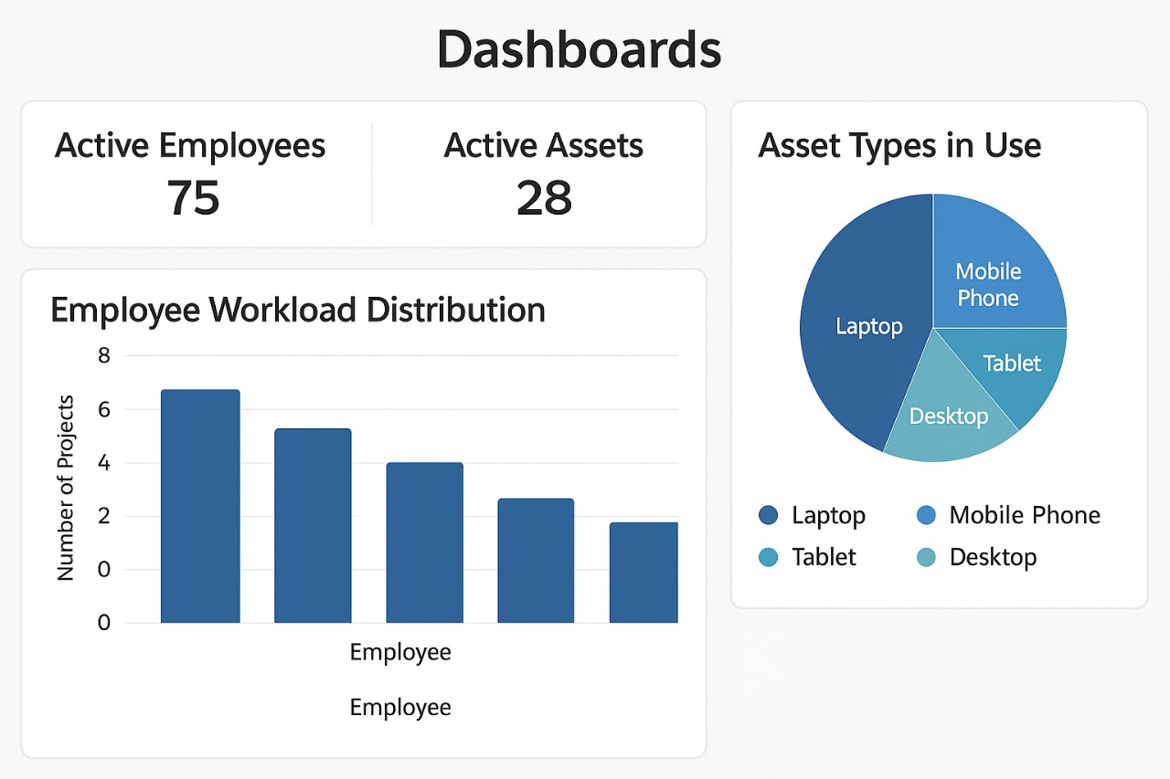

📌 Summary of Results

* The system accurately recorded and managed employee, project, and asset data as intended.
* Automation worked as expected, with flows triggering on assignment updates and generating notifications.
* Reports and dashboards provided real-time insights and loaded within acceptable performance thresholds.
* The solution met functional and non-functional acceptance criteria with no critical defects at the time of deployment.

**9. ADVANTAGES & DISADVANTAGES**

**9.1 Advantages**

The *Workforce Administration Solution* offers several key benefits that directly address the challenges faced by the organization:

1.Centralized Data Management

* All employee, project, and asset data is stored and managed in a single, unified platform, reducing fragmentation and inconsistencies.

2.Automation of Administrative Tasks

* Flows and processes automate assignments, notifications, and updates, minimizing manual effort and human error.

3.Real-Time Reporting and Dashboards

* Managers and HR personnel have instant access to up-to-date information on employee workload, project assignments, and asset distribution, enabling informed decision-making.

4. Scalability

* The solution is designed on Salesforce’s robust platform, allowing easy scalability as the organization grows in size and complexity.

5. Role-Based Access Control

* Ensures that sensitive data is protected, and users can only access information relevant to their roles.

6. Audit-Readiness

* The solution maintains detailed records of assignments and changes, simplifying compliance and audit processes.

7. Improved Employee Accountability

* Clear visibility of asset assignments reduces the chances of asset misplacement or loss.

9.2Disadvantages

While the solution delivers strong value, certain limitations and considerations exist:

1. Initial Setup Effort

* The configuration of custom objects, relationships, flows, and reports requires significant upfront planning and effort, especially for complex organizational structures.

2.Salesforce Licensing Cost

* Dependence on Salesforce means organizations need appropriate licenses, which could be a cost consideration, particularly for small organizations.

3. Customization Dependency

* Further customization or enhancements (e.g., integrations with external HR systems) may require Salesforce expertise or development resources.

4. Change Management

* Introducing the system may require user training and adaptation, as employees and managers shift from manual or legacy processes to the new solution.

**Summary**  
The *Workforce Administration Solution* provides a powerful foundation for improving workforce and asset management, with its advantages far outweighing the limitations. The identified disadvantages can be mitigated through careful planning, user training, and ongoing support.

**10. CONCLUSION:**

The **Workforce Administration Solution** effectively fulfills a vital organizational need for a unified, automated system that manages employee project assignments and asset allocations with precision and efficiency. By leveraging the robust capabilities of the **Salesforce platform**, this solution not only centralizes critical workforce data but also ensures that information is **secure, scalable**, and **accessible in real time**. This eliminates the common pain points associated with fragmented systems and manual tracking methods, such as data inconsistencies, inefficiencies, and human error.

Through the implementation of **automated workflows**, the solution streamlines repetitive administrative tasks like assigning projects or tracking assets, significantly reducing the workload on HR personnel and managers. **Dynamic dashboards and real-time reporting tools** empower decision-makers with actionable insights, facilitating smarter resource allocation and improved performance monitoring.

Furthermore, the integration of **role-based access controls** ensures that sensitive workforce data is protected and that users can only interact with information relevant to their responsibilities—enhancing security and organizational compliance. This layered security model supports adherence to company policies and industry regulations, while also fostering user trust.

The solution's design prioritizes not only operational efficiency but also **employee accountability and transparency**, contributing to a more structured and responsive workforce environment. Its modular, cloud-based architecture ensures that the system can **evolve with the organization's growth**, supporting future expansions such as integration with external HR systems, mobile optimization, and AI-driven analytics.

In conclusion, the Workforce Administration Solution is more than just a digital tool—it's a **strategic enabler** for organizations aiming to modernize their workforce management processes. It creates a **solid foundation for digital transformation**, enhances organizational agility, and positions the enterprise for **sustainable innovation and long-term success** in workforce administration.

**11. FUTURE SCOPE:**

While the *Workforce Administration Solution* provides a robust foundation for workforce and asset management, there are several opportunities for enhancement and expansion to meet evolving organizational needs:

**11.1 Potential Enhancements**

1.Integration with External HR and ERP Systems

* The solution can be integrated with platforms like Workday, SAP, or Oracle HR to enable seamless data exchange for employee records, payroll, and leave management.

2.Advanced Analytics

* Implement AI-powered analytics to provide predictive insights into employee workload, project success likelihood, or asset utilization trends.

3. Mobile App / Salesforce Mobile Optimization

* Enhance mobile usability further by developing a dedicated mobile app or optimizing the Salesforce Lightning interface for field use by employees and managers.

4. Self-Service Portals

* Allow employees to view their assignments, request assets, or update their information through self-service interfaces, reducing HR workload.

5. Enhanced Asset Tracking

* Integrate with IoT or barcode/RFID technologies for real-time physical tracking of assets.

**11.2 Scalability and Adaptability**

* **As the organization grows**, the solution is designed to seamlessly **scale** to accommodate increased volumes of employee data, project records, and asset inventories **without requiring major architectural changes or reconfiguration**. Thanks to the flexible nature of the Salesforce platform, administrators can easily extend the existing data model, add new custom objects or fields, and integrate additional automation processes as needed. Whether the organization expands across departments, regions, or even globally, the solution can be adapted to support larger teams, more complex workflows, and higher volumes of transactions — all while maintaining performance, security, and data integrity.
* **Future modules** can further enhance the Workforce Administration Solution by introducing advanced features such as:
  + 🔹 **Time Tracking**: Capturing the amount of time employees spend on different projects or tasks to support productivity analysis, billing (for client projects), and workload management.
  + 🔹 **Performance Reviews**: Incorporating tools to evaluate employee performance periodically through structured reviews, feedback collection, and goal tracking.
  + 🔹 **Skills Management**: Maintaining an up-to-date repository of employee skills, certifications, and proficiencies to aid in better project-team matching, training recommendations, and succession planning.

These future enhancements would transform the system into a **comprehensive Workforce Management Suite**, offering end-to-end capabilities from onboarding to performance evaluation, thereby supporting both operational needs and strategic human capital planning.

**11.3 Security Enhancements**

* As data privacy regulations and cybersecurity threats continue to evolve, future iterations of the Workforce Administration Solution can incorporate a range of advanced security features to ensure stronger compliance and risk mitigation. These enhancements may include:
* Granular Permission Controls: Introducing more refined user access levels beyond standard roles and profiles. For example, enabling field-level and record-level access customization based on user responsibilities or department, ensuring that sensitive data is only visible and editable by authorized personnel.
* Data Encryption Enhancements: Leveraging Salesforce Shield or other native encryption mechanisms to apply at-rest and in-transit encryption on critical fields such as employee records, asset details, and project information. This will help protect sensitive data from unauthorized access, especially in industries with strict data protection requirements.
* Comprehensive Audit Trails: Implementing robust logging and monitoring tools that track every change made in the system — including who made the change, what was modified, and when it occurred. These immutable audit logs are crucial for internal audits, external compliance reviews, and incident investigations.
* Compliance with Global Regulations: Ensuring alignment with regulatory frameworks such as GDPR (General Data Protection Regulation), HIPAA (Health Insurance Portability and Accountability Act), and others by:
* Supporting data anonymization and user consent tracking.
* Enabling data retention policies and right-to-erasure processes.
* Maintaining audit logs for data access and sharing activities.
* These security upgrades would not only strengthen the system’s defense mechanisms but also build organizational trust and user confidence in handling sensitive workforce data, making the solution viable for deployment in highly regulated industries.

**11.4 Global Deployment**

As organizations expand their operations across geographical boundaries, the Workforce Administration Solution is well-positioned to support multi-region and multi-country deployment with minimal adjustments. Built on the flexible and highly configurable Salesforce platform, the solution can be tailored to meet the diverse needs of a global workforce. Key global deployment capabilities include:

* Localization Support: The system can be customized to support multiple languages, enabling users in different countries to interact with the application in their preferred regional language. This improves user adoption, reduces training friction, and enhances accessibility for non-English-speaking users.
* Multi-Currency Enablement: For organizations operating in international markets, the solution can be configured to handle multiple currencies, ensuring accurate financial data and reporting in each region. Salesforce’s native multi-currency support ensures that all monetary values (e.g., asset valuation, cost tracking) are automatically converted and recorded based on the appropriate exchange rate.
* 🔹Region-Specific Compliance: The solution can be adapted to comply with local data protection laws and employment regulations, such as GDPR in Europe, CCPA in California, and APPI in Japan. It supports:
  + Data residency controls (e.g., selecting preferred data centers).
  + Custom legal disclaimers and consent forms.
  + Country-specific user roles, access permissions, and workflows.
* Time Zone and Date Formatting: Regional settings such as time zones, date formats (e.g., DD/MM/YYYY vs. MM/DD/YYYY), and workweek definitions can be adjusted to align with local norms, ensuring accuracy in scheduling, reporting, and communication.
* Scalable Architecture for Global Growth: As new branches, offices, or business units are established in different regions, administrators can quickly onboard new users, replicate workflows, and roll out the solution across new geographies — without disrupting the existing ecosystem.

These capabilities make the Workforce Administration Solution not only a powerful tool for centralized operations but also a globally adaptable platform, ready to meet the demands of large, international enterprises seeking consistent yet regionally responsive workforce management.

**11.5 Summary:**  
The Workforce Administration Solution is purposefully designed with flexibility, scalability, and future-readiness at its core. Its modular architecture on the Salesforce platform not only addresses current workforce administration challenges but also provides a robust foundation for continuous innovation and expansion.

The solution is well-equipped to evolve alongside the organization’s growing needs—whether that involves integrating with external HR and ERP platforms, enhancing mobility and self-service capabilities, or incorporating advanced analytics and automation tools. With built-in support for global deployment, security enhancements, and customizable modules, the platform is adaptable across industries, regions, and compliance landscapes.

By planning for these enhancements early and aligning them with strategic business goals, organizations can ensure that their workforce management systems remain agile, resilient, and aligned with modern technological and operational expectations. Ultimately, these future improvements will not only support internal efficiency but also drive greater employee satisfaction, transparency, and organizational excellence in the long term.

**12. APPENDIX**

This appendix provides supplementary materials and references used throughout the development of the **Workforce Administration Solution**. These resources support the design decisions, implementation details, and performance validation described in the main report.

**📁 12.1Terminology**

| **Term** | **Definition** |
| --- | --- |
| **Salesforce** | A cloud-based CRM and platform-as-a-service used to build business apps. |
| **Custom Object** | A user-defined data structure in Salesforce for storing organization-specific data. |
| **Flow / Process Builder** | Salesforce tools for automating business processes without code. |
| **Role-Based Access** | A security model where access is granted based on the user's role. |
| **Asset** | A physical or digital item assigned to an employee (e.g., laptop, phone). |
| **Dashboard** | A graphical representation of data using charts, graphs, and metrics. |
| **Junction Object** | A Salesforce object used to implement many-to-many relationships. |
| **Validation Rule** | Logic used to enforce data entry standards and prevent invalid records. |

**📄 12.2. Documents & Artifacts**

| **Item** | **Description** |
| --- | --- |
| Project Charter | Initial documentation outlining project scope and objectives. |
| Requirement Specification | Detailed list of functional and non-functional requirements. |
| Data Model Diagram | Visual representation of custom objects and their relationships. |
| Solution Architecture Diagram | High-level overview of system components and interactions. |
| Test Case Document | Comprehensive list of test cases with expected outcomes. |
| Sprint Planning Sheet | Breakdown of tasks, user stories, and story point allocations. |
| Burndown Chart | Sprint-wise visual tracking of task completion. |

**🧪 12.3. Tools & Platforms Used**

* **Salesforce Lightning Platform**
* **Salesforce Flows and Process Builder**
* **Salesforce Reports and Dashboards**
* **Salesforce Sandbox (for testing)**
* **Draw.io / Lucidchart** (for architecture and ER diagrams)
* **Google Docs / Sheets** (for planning and documentation)

**📸 12.4. Screenshots & Visuals**

* Employee record page
* Project and asset assignment interfaces
* Automation setup (Flow or Process Builder)
* Sample reports and dashboards
* Visual diagrams (Data Flow Diagram, Architecture, Empathy Map, etc.)

**🔗 12.5. References**

* Salesforce Documentation: <https://help.salesforce.com>
* Salesforce Developer Guide
* GDPR Compliance Guidelines
* Agile Methodology Principles
* IEEE Software Engineering Standards (for testing and documentation)